# Moving Average Convergence Divergence (MACD)

**What is MACD?**

MACD (Moving Average Convergence Divergence) is one of the most popular and widely used technical analysis Indicators.  MACD indicator was invented by Gerald Appel in 1960s. In this section we will discuss about it's concepts, construction, types of trading signals with examples and also an insight of MACD trading strategies.

**Introduction**

Moving Average Convergence Divergence is a momentum Oscillator and can be used to determine the momentum of the price action. MACD is comprised of two EMAs ([Exponential Moving Averages](http://www.forexabode.com/exponential-moving-average/)) of two different time periods i.e. one for longer time period and another for shorter period. The most common EMA's used for MACD are of 12 periods and 26 periods.

MACD is unique as it has the elements of lagging indicator as well as leading indicator. While saying this please note that no indicator can be an absolute leading indicator. The reason is simple as the signals are generated only after some confirmation of the direction of the price action. Please note the following points for the statement made above.

1. [Moving averages](http://www.forexabode.com/technical-analysis/indicators/moving-averages/) are trend-following indicators. Trend following indicators are those which tend to confirm the trend after the trend has begun and hence are classified as lagging indicators.
2. However, by taking the differences in the moving averages, this indicator incorporates the aspects of momentum or leading elements. Because of this it tells us in advance (with a slight time lag) about the possibilities of a reversal in the ongoing trend. This is explained later in this tutorial.

MACD as Momentum Oscillator

MACD falls in the category of momentum oscillators. During a bullish or bearish market it helps us in analyzing if the momentum of the trend is getting stronger or is it weakening. In the absence of a trend or during a weak trend it tends to generate more false signals and hence is those situations we should avoid the use of this indicator.

**Price Action Momentum In Trading:**

In trading the momentum is the rate of price increase during an uptrend and rate of price decrease during a downtrend.

Let's try to see a hypothetical example of the price action of EUR/USD.

|  |  |  |  |
| --- | --- | --- | --- |
| **Day** | **Opening Price** | **Closing Price** | **Change (Pips)** |
| Day 1 | 1.3100 | 1.3185 | 85 |
| Day 2 | 1.3185 | 1.3285 | 100 |
| Day 3 | 1.3285 | 1.3300 | 115 |
| Day 4 | 1.3300 | 1.3340 | 40 |
| Day 5 | 1.3340 | 1.3370 | 30 |

Now as we see that the price has been continuously increasing and indicates an uptrend. Let's say that this is the last day of the week i.e. day 5 and we decide to take a long position. The fact we are ignoring here is that even though the prices have been increasing but there was a sudden drop in the momentum after Day 3. It may indicate the possibilities of a reversal of the trend or a consolidation before the uptrend resumes.

Momentum takes out the illusion of the trend even if there is a constant upward or downward movement. And it tells us if the rate of change is slowing down or going up. Buying is signaled when the uptrend is gaining momentum and selling is signaled when the downtrend starts gaining momentum. MACD helps us in analyzing this

Interpretation

**MACD and Trends:**

Let's assume that there is an ongoing uptrend. Before entering the long position we would like to know if the momentum of the upward momentum is keeping up or there is any loss of momentum recently. A loss in the momentum may indicate the possibilities of a consolidation or even a reversal in the trend. Moving Average Convergence Divergence helps us in estimating the momentum of the trend.

During an uptrend we would like to go for a long position when the uptrend is gaining momentum as in that case we can expect further upwards moves. Similarly in a downtrend we would like to enter a short position when the downward momentum is getting stronger as further drop in the price can be expected. But when the momentum is slowing down in either case then we may need to hold ourselves from entering a market and may prefer to wait and watch. Hence knowing about the momentum of the trend is very important and MACD helps us in determining that.

Calculation

**Formula**

**MACD = (Shorter term moving average) - (Longer term moving average).**

**Period Settings**

The most common period setting for MACD is 26, 12, 9. Here “26” is the EMA of previous 26 periods, “12” is the EMA of previous 12 periods. And MACD would be the line constructed by joining the points which we get by deducting the EMA(26) from EMA(12). In our case it means MACD = EMA of 12 periods – EMA of 26 periods.

Uptrend: If the EMA of previous 12 periods (more recent data) is going over the EMA of 26 periods (longer time frame data), it would indicate that recently the prices have started moving upward.

Downtrend: If the EMA of previous 12 periods i.e. the more recent prices is going below the EMA of 26 periods, it would indicate that in recently the prices have started going down.

Now how do we find out the momentum by using MACD? Please see the chart 1 below.

**Chart 1:**

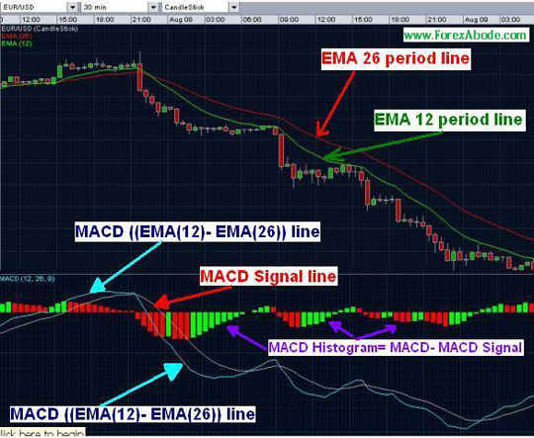

If we see the above EUR/USD chart, we find that there is one more line which is running along with the main MACD line. This second line is known as “MACD Signal Line”.

The Signal line is derived by taking the Exponential Moving Average (EMA) of the MACD line. The setting MACD (26,12, 9) means that we are taking the EMA of MACD for pervious 9 periods.

We have already seen that if the shorter-term moving average is more than the longer term moving average, it indicates an uptrend situation on that time frame chart. The question now is that how do we find out the momentum of the uptrend. We find the momentum by comparing the current difference with the average difference over past few periods.

To simplify we check the current "EMA of 12 periods – EMA of 26 periods" and we compare it with the average "EMA of 12 periods – EMA of 26 periods" for the past few periods. In our case i.e. (MACD 26, 12, 9) it is the average of the differences of past 9 periods.

With MACD (26,12,9) what we are calculating is as follows:

1. Moving average of closing prices for past 12 periods, say “X”
2. Moving average of the closing prices for past 26 periods, say “Y”
3. Difference “X-Y” (MACD). If it is positive then it’s a signal for uptrend and if negative than of downtrend.
4. Moving average of “X-Y” for past 9 periods, say “Z”
5. If MACD line (connecting all “X-Y” points) moves above the trigger or signal line (line connecting all “Z” points) then it would indicate that the current rate of upward momentum has gone higher than the average rate of previous 9 periods. This indicates that the uptrend is increasing or gaining momentum and it may be the time to buy.

Opposite of points 1 to 5 above i.e. when the MACD goes below the signal line would indicate the time to sell.

Summary of Construction

1. The main line, sometimes called as MACD fast line, is calculated by taking the difference of two Exponential Moving Averages (EMAs) - popularly the 12 and 26 period EMAs.
2. The signal line, sometimes called as the trigger line, is an EMA of the MACD main line. This popularly uses 9 period EMA of the MACD main line.
3. The MACD histogram is a bar chart that shows the difference between the two lines (main line and signal line) Mathematically, it is the signal line subtracted from the MACD main line (Histogram = Main Line – Signal Line).

MACD Trading Strategies:

For trading, the main signals we look for are as follows:

1. Main line crossing the signal line.
2. MACD main line crossing the center line i.e. moving from positive to negative or vice versa.
3. Divergence / Convergence.

**Crossover Signals:  
  
1) MACD main line crossing signal line (trigger line):**

A trading signal is generated when the main line crosses the signal line.

**Bullish signal - MACD line moves over the signal line:**

A bullish moving average Crossover occurs when the main line moves above its signal line

Such move indicates that the prices are gaining upward momentum. If the MACD was already in positive range, indicating an uptrend, then it would mean that the uptrend is getting stronger. If the MACD was in negative range then it may mean that a reversal or upward correction can be expected. Please check charts 2 & 3 below.

**Bearish Signal - MACD line moves below the signal line:**

A bearish moving average Crossover occurs when MACD moves below its signal line.

Such move indicates that the recent downward momentum is getting stronger than the previous. This is just opposite to the bullish signal we explained above. In this case if the MACD was already in negative range then it indicates that the existing downtrend is getting stronger. If the MACD was in positive range then it signals the possibilities of a reversal or correction of the existing uptrend. Please check charts 2 & 3 below.  
  
Please keep in mind that MACD works better during a reversal of a trend (uptrend to downtrend or vice-versa) and may tend to give a lot of false signals when the price action is in narrow range.

**2) MACD line crossing the center line:**

* A Bullish Center line Crossover occurs when the main MACD line moves above the zero/Center line. This gives a signal that momentum has reversed from negative to positive (from downtrend to uptrend).
* A Bearish Center line Crossover occurs when the main line moves below the zero/Center line. This gives a signal that momentum has reversed from positive to negative (from uptrend to downtrend).

**Examples of signals**

**chart 2**

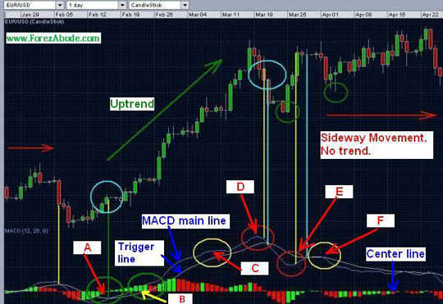

Please take a note of the points A to F in the above chart for EUR/USD:

**Point A and associated area within the green circle:**

The MACD main line moves over the signal line: This gives a “buy” signal or a signal indicating the possibilities of a correction or reversal of the downtrend. Please note that prior to this crossover the MACD was in the negative zone and was representing a bearish market. After this signal was generated the price continued moving upwards.

**Point B and associated area within the green circle:**

At point “B” the MACD line crosses over the “Center line”. This again signals that an uptrend may start.

**Point D and associated area within the red circle:**

At point “D” the MACD line moved below the signal line and hence indicated that we could expect a downward correction or even a reversal of the uptrend. Please note at prior to this crossover MACD line was in positive zone and was indicating a bullish market. In case we were already holding a long position for EUR/USD then this signal suggested to close the position. In case we were not holding any bought position before the point “D”, we could short-sell the currency pair to benefit from the possible downward move.

**Point E and associated area within the red circle:**

At point E, the MACD line started crossing over the signal. This singled that the prices might start to go up. This signal did not prove to be a good signal as the MACD line did not really move up sharply.

Please take a note of the areas within the circles in the above charts. Prior to each crossover there has been a divergence. For example before the crossover at point D, the MACD line had started moving downwards sharply. Similarly within the area of point “E”, the MACD line had started moving upwards sharply before the actual crossover took place. In the area “C”, the MACD line started moving down but this move was not sharp. These sharp divergences may also indicate the possible change of the trend.

Convergence and Divergence

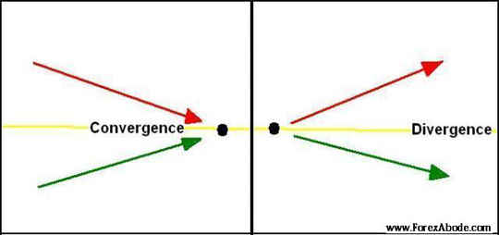

**Divergence and Convergence in Technical Analysis**

In MACD analysis it is not only the crossover signals which we need to focus on but we also need to watch the developments of the subsequent highs and lows. When the subsequent high or low points (peaks and valleys) in MACD line are going lower than the previous peaks or lows, it may give a good signal for an emerging down trend. Similarly if the subsequent high and low points in MACD line are going higher than the previous ones, it may give a good signal for an emerging uptrend.

**Chart 3**

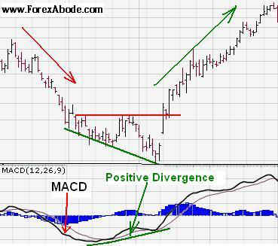

**Chart 4**

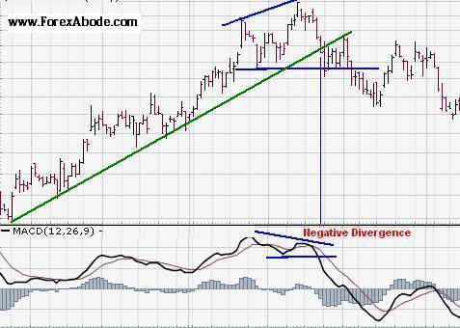

# MACD Histogram

MACD generates buying or selling signals primarily as a lagging indicator even though it has some characteristics of leading indicators as well. The time lag may result in missing some important market moves. Because of the lagging characteristics, at times, we may get the signal quite late and hence may miss the opportunity to take the trading decision at the right time. The MACD Histogram helps in speeding up the signals by enabling us to anticipate the MACD crossover in advance.

MACD Histogram was developed by Thomas Aspray in 1986 for reducing the time lag of the [MACD](http://www.forexabode.com/technical-analysis/macd/) crossover signals as mentioned above.

## Definition and Construction

The MACD Histogram represents the difference between the MACD and its signal line. For ready reference, in our example, the signal line or trigger line is the 9-day [EMA](http://www.forexabode.com/exponential-moving-average) of main MACD.

This difference between the MACD and its signal line is presented as bars. Please refer the following illustration. This bar construction is called MACD Histogram.

### Histogram illustration

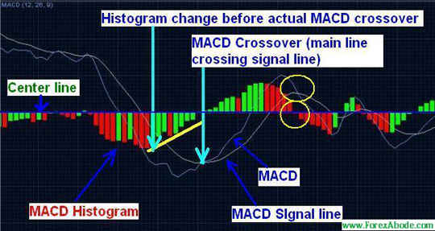

Histogram makes center line crossovers and divergences easily identifiable. If you look at the above chart, you would note that the Histogram makes a center line crossover whenever the MACD crosses the trigger line. In the same chart the two yellow circles have been drawn as an example of the same. You may please note that at elsewhere  also the Histogram crossovers with the center line correspond to the MACD crossovers with the trigger line.

If the value of MACD is larger than the value of its 9-day EMA i.e. MACD line is above the trigger line, then the value on the MACD Histogram will be positive. Conversely, if the value of MACD is less than its 9-day EMA i.e. MACD is below the trigger line, then the value on the MACD Histogram will be negative.

Further increases or decreases in the gap between MACD and its trigger line is reflected in the MACD Histogram. Whenever the gap increases, the histogram bars becomes longer and vice-versa. Hence the longer bars indicate in the increase in the momentum and shorter bars reflect that the momentum of the ongoing trend is slowing down.

MACD Histogram was designed to anticipate a [moving average](http://www.forexabode.com/technical-analysis/indicators/moving-averages/) crossover in the MACD. This is achieved by noting the Positive and Negative[Divergences](http://www.forexabode.com/technical-analysis/macd-divergence/) in the MACD-Histogram.

* A Positive Divergence forms when the MACD Histogram forms a higher Low and the MACD continues going lower.
* A Negative Divergence forms when the MACD Histogram forms a lower High and the MACD continues going higher.

Please see the following chart to understand about this positive and negative divergences.

### Negative and Positive Divergences

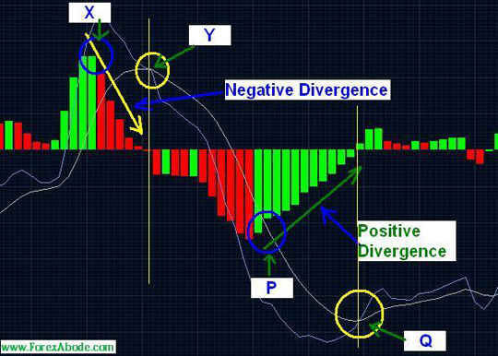

### Explanation And Interpretation of MACD Histogram

Please refer the above chart. From point “X”, though the MACD continued going higher for some time but the Histogram started going lower. This was a case of negative divergence. This fact signaled that a bearish move could be expected. The actual MACD crossover took place at point “Y”. Point “Y” would signal us about the downward move and hence to “Sell” but Histogram indicated it earlier at point “X”.

Similarly, from point “P” though the MACD continued to go lower but the Histogram started going up. This was a case of positive divergence. This positive divergence indicated the possibilities of a bullish move. The actual MACD crossover took place at point “Q”. Point “Q” signaled us for buying but Histogram had already indicated it at point “P”.

Divergence between MACD and the MACD Histogram is the main tool used to anticipate moving average crossovers. A positive divergence in the MACD Histogram indicates that the MACD is strengthening and could be on the verge of a bullish moving average crossover. On the other hand a negative divergence in the Histogram indicates that the MACD is weakening and market may start falling soon.

### Notes:

The MACD Histogram is an indicator of an indicator because this was designed to predict the movement of another indicator i.e. MACD. This may make it to generate false signals more often as it is not “directly connected to the “price action”. MACD is connected to the “price action” and Histogram is connected with MACD. Because of this fact please avoid using MACD Histogram in isolation and either use it as an early warning system with the MACD or use it longer time frame charts like daily chart. On short-term charts you may come across the false signals quite frequently. Another piece of advice would be to check the historical patterns on different common time frame charts to analyze the time frame with least number of false signals.

As true with all technical indicators, analyze the short time frame charts as well as a longer-time frame charts. If the signal from longer-term chart and shorter-term charts are in synch (agree to each other) then the MACD signals would have better probability of going true.

Please be careful of small and shallow divergences as those may create false signals. One method to avoid small divergences is to look for larger divergences with two or more readily identifiable peaks or troughs. Compare the peaks and troughs from past action to determine their significance.

The following chart with MACD and MACD Histogram is for exercise. Please take note of each point of change with the reference of the above explanation. There is one point where MACD-Histogram signal was not effective even though it was not false. What it means is that at other points the Histogram gave early signals to buy or sell and those resulted in significant moves but at this particular point though the indicated move came but the movement thereafter was not significant.

### MACD Histogram Exercise Chart

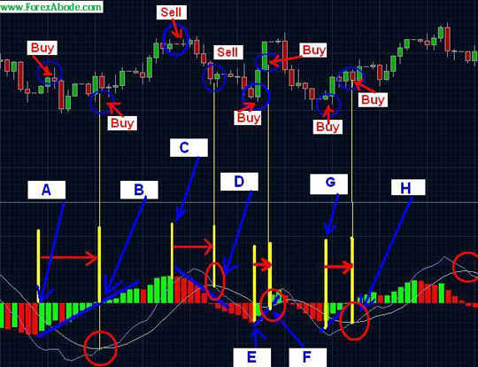

As far as the question above is concerned, the answer is point “A” (MACD Histogram signal) and point “B” (MACD crossover signal). The Histogram signal was early for buying but it proved to be too early as the market kept on going down instead of going up. At other points the Histogram signals were early and also resulted in significant moves and hence profits. But then, who says that the world is perfect MACD Histogram - 4

## MACD Trading Strategies

MACD (Moving Average Convergence and Divergence) is a commonly used Forex technical indicator, but has flaws in that its data lags behind real time. Here are some methods of making better use of [MACD](http://www.forexabode.com/technical-analysis/macd) by refining the results to include the possibility of change.

The meaning of the acronym MACD, or Moving Average Convergence and Divergence, indicates an intrinsic problem in Forex trading: it is a moving average, and hence the data it offers will by definition always be historical. Therefore, any radical changes shortly before you use these crossover trading signals as a basis for Forex buy or sell decisions could have a considerable negative impact on your result, particular where trends are weak or the market is ranging.  What can be done to avoid this?

When the trend is slowing down or is already fairly slow, the main problems you will be facing using MACD relate to your entry position and your profit taking position thus:

1. Entry Signal:  Because the data is historical with a time lag before presentation, the price may have reached the reversal point already before the entry signal is generated. That may be because that during the time delay with a weak trend, the trend weakens further and the market is about to reverse. You therefore enter at an inflated price.

2. Exit:  When MACD indicates the crossover with the signal line when you should exit and sell the price may already have reversed to an extent that any profits you realize are significantly lower that they could have been had you been aware of the reversal in real time, rather than delayed time. If problem 1 coincides with problem 2 then you could conceivably lose on the deal and will certainly make a significantly lower profit than expected from the analysis.

So how can you get over these problems, and improve the accuracy of using MACD for an indication of when to enter or take profit? Forex trading analysts, Albin, Gunter and Kain proposed ignoring short-term MACD signals by waiting three days after a crossover has been indicated, and then acting if no further crossover has taken place during those three days. They called this refinement MACD R1.

### MACD -R1 Revision

If another crossover took place, they suggested you wait a further three days (or periods) before taking a position. They also suggested that in order to avoid losing profit by exiting too late after the reversal had taken place you should determine the profit-taking levels in advance. So rather than taking the chance of making a small, or even no profit, due to the lag of the MACD indicator, you should close the trade at a predetermined gain - say 3% or 5% over the entry. Also close the position if crossover occurs prior to the predetermined % target.

Although this might seem sensible, it has weaknesses: There will still be a certain number of false signals since you will never be able to overcome the lag built into historical data, and also, if you close at 3% or even 5% and the trend becomes strong and the profit increases to even 10%, then you will lose out when there was no need to do so.

What then? Does it still make sense to go with R1 or is there some other possibility to improve the accuracy of MACD R1?  In fact, there is, and Albin, Gunter and Kain suggested a further revision, named MACD R2. This was intended to overcome the remaining false signals to as low a level as possible.

### MACD -R2 Revision

One serious problem with R1 in Forex trading was that between the initial signal and that after three periods (or days), you took a position to buy or sell.  However, it is possible for the market to suddenly reverse then, and for another crossover to take place, resulting in you losing money in your Forex trading. Why should this happen?

Simple: after you waiting 3 periods after the original crossover, and a second reversal crossover did not take place, you took a position, but the MACD and signal line may have come very close together without crossing over. A reversal was indicated, but you couldn't see it and so because the data was historical, the lag meant you had taken a position very close to or even after the second crossover and made a wrong decision by assuming the original crossover trend would continue.

Here's how MACD R2 deals with this possibility:

R2 adds a predetermined condition prior to you taking a position - there must be a pre-determined difference between the signal line and MACD after the three periods. This should then make sure that there is no imminent crossover that can ruin your trade.

Example of MACD R2

So to put all of this into chronological order, let's take a Forex trading hypothetical situation where you set a figure of 1.5% as the minimum difference between signal line and the MACD after three periods and that in this case a period is a day.

A:  Day 1 - MACD and signal line cross over.   
B:  Day 4 - You have waited 3 days and no more crossovers have occurred.  
C:  Check the price - assume that to be 120.00  
D:  Check MACD - assume it to be 6 (i.e. 12 Day EMA-26 day EMA = 6)  
E:  Check the signal line - that is 4  
F:  Calculate the difference and compare to your minimum difference figure: 1.5%

Formula is 100\*(MACD -Signal line after 3 periods)/price  
= (6-4)\*100/120 = 1.67%

This is greater than your predetermined 1.5% so you can go ahead with a position.  Had the sum been less than 1.5% you would have neglected the signal.

Note on MACD:  The MACD is derived from the difference between two [moving averages](http://www.forexabode.com/technical-analysis/moving-averages): those of a shorter period and of a longer period. Hence the 12-day and 26-day moving averages used above.

If the term MACD (26,12,9) is used, then:  
the MACD for a specific point = EMA for 12 periods - EMA for 26 periods. Periods can be typically days. The 9 refers to taking the EMA of the MACD for the previous 9 periods.

The MACD signal line = the [EMA](http://www.forexabode.com/exponential-moving-average) of the MACD line.

You can use this technique and formula in Forex trading to judge when and when not to take a Forex position, whether to buy or to sell, with more confidence that had you simply used the MACD itself.

# Fibonacci Retracement

## Introduction

Fibonacci retracement levels are based on Fibonacci numbers and Fibonacci ratios, which find their ways in all walks of life. There are various trading tools based on Fibonacci ratios but Fibonacci retracements lead the way and are very commonly used in the technical analysis.

## Retracement Levels

What goes up comes down and what goes down comes up. Even during very strong trends prices take temporary reversal and consolidate quite frequently. It’s like taking the breathing time before moving ahead. The retracement levels derived from Fibonacci ratios indicate the levels to which the price action may consolidate before continuing in the direction of the ongoing trend

### Graphical illustration 1

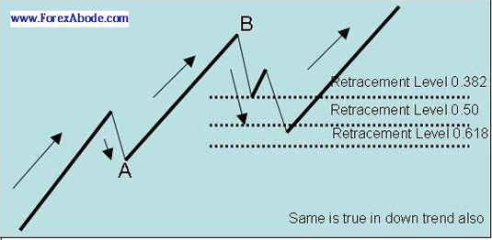

### Graphical illustration 2

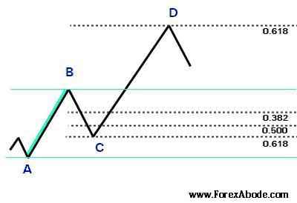

Before we discuss about Fibonacci retracements, let's see what are Fibonacci numbers and how are these applied in the technical analysis

## Fibonacci Sequence

Fibonacci sequence is a series of numbers in which each number is the sum of the previous two numbers. The first two numbers of Fibonacci series are 0 and 1 or the typical binary numbers. Let's start with these two numbers and check how the series develops:

* First two numbers: 0, 1.
* Third number = 0+1 = 1.
* The extended series = 0, 1, 1.
* Fourth number = 1 + 1 = 2.
* The extended series = 0, 1, 1, 2.
* Fifth number = 1 + 2 = 3.
* The extended series = 0, 1, 1, 2, 3.

If we continue adding the latest two number to get the next number, we get a series of numbers as follows:

0, 1, 1, 2, 3, 5, 8, 13, 21, 34, 55, 89, 144, 233, and so on.

The above series is nothing but Fibonacci series of numbers or Fibonacci sequence.

## Fibonacci Ratios

The importance of Fibonacci sequence lies in Fibonacci ratios. Fibonacci ratio relates to the famous Golden ratio which is quite important in mathematics, art & architecture and even in nature.

## What is the Golden Ratio?

Golden ratio is derived by two numbers when the ratio of those two numbers is same as the ratio of the sum of those two numbers to the larger number. This is explained as follows:

1. Let's assume we have two numbers "X" and "Y" where X is greater than Y i.e. X > Y.
2. The sum of two numbers = X+Y.
3. The ratio of the two numbers = X/Y.
4. The ratio of the sum of these two numbers with the greater of these two = (X+Y)/X
5. With the above the "X" and "Y" would have a "Golden Ratio" if (X/Y) = (X+Y)/X

If we analyze Fibonacci sequence we will find that the consecutive numbers in the series are all with the Golden ratio. Let's pick up two numbers e.g. 233, say X and 144, say Y.

1. Now X/Y = 1.618
2. And (X+Y)/X = (233+144)/233 = 377/233 = 1.618.
3. Hence (X/Y) = (X+Y)/X and that makes it a "Golden ratio".

### Constant ratios

Now  let's have a look on the Fibonacci sequence once again:

0, 1, 1, 2, 3, 5, 8, 13, 21, 34, 55, 89, 144, 233, and so on.

Now let's pick up any four consecutive numbers after 8 and check the ratios. Let's say the first set we pick up is 8, 13, 21 and 34. The ratios for these are as follows:

1. 8/34 = 0.236
2. 13/34 = 0.382
3. 21/34 = 0.618

Let's pick up another set of four numbers, let's say 55, 89, 144 and 233. Now the ratios for these numbers are as follows:

1. 55/233 = 0.236
2. 89/233 = 0.382
3. 144/233 = 0.618

This is the essence of Fibonacci numbers that the ratios will remain constant. Please note that the numbers at the beginning of the series i.e. 2, 3 and 5 etc only result in the approximate ratios but not the exact. The exact ratio comes into the picture as mentioned above and then the ratios remain constant as we move ahead with the numbers.

These Fibonacci ratios can be found in nature, science, architecture, music, art. A few examples of these ratios can be found in pine cones, sunflowers, pineapples, palm trees, spider webs, snail shells, DNA molecules and millions of other things in the universe.

### Fibonacci ratios and retracements

The Fibonacci ratios as percentage are what Fibonacci retracements in technical analysis are all about. The 0.236 is 23.6% retracement, 0.382 is 38.2% retracement and 0.618 is 61.8% retracement. The most common retracement levels are as follows:

1. 38.2%
2. 50%
3. 61.8%

In technical analysis, Fibonacci retracement Levels are used as support and resistance levels. During an uptrend when the price consolidates downwards then these retracement levels become support levels. Similarly during a downtrend when the price retraces for correction or consolidation then these levels become resistance levels.

### 

### Fibonacci in Technical Analysis

The common occurrence of Fibonacci ratios in the life made technical analysts explore the possibilities of these ratios to appear in the rapidly changing prices of commodities, stocks and then Forex also. We can always argue about the relevancy of this and debate about the logic. If we do that then we will end up winning as we will fail to find any logic behind it. But then nothing is logical speculative markets. Markets move because of speculations and traders need some grounds or reasons for those speculations. If a lot of volumes get traded because of the beliefs on any technical analysis indicator then those volumes become the driving force for the momentum in the direction of those trade positions. In simple way, if lots of people are buying then the prices would go high and if large volumes are being sold the prices would fall further.

### When to use?

The first indication of a consolidation towards the Fibonacci retracement levels is when during a trend there is a slow-down in the momentum and the price-action starts going in the sideways. This situation may be an opportunity to enter the market to target the retracement levels.

When you come across such situation then you may like to check for a trading signal generated by some other indicator e.g. MACD or moving average crossover as a confirmation for the entry.

Please refer the following charts:

#### Illustration on Forex chart - 1

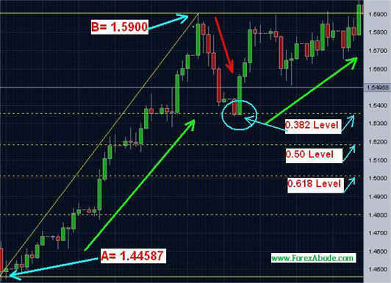

In the Forex chart 3 there is was a strong upward move from point "A" to point" B". The price action found resistance at point B and fell. Just see how perfectly there was a drop to exactly 38.2% level before moving up again?

Let's check the price movement in figures:

* A = 1.4458
* B = 1.5900

Hence total upward move was B – A = approx 1442 Pips

The price dropped to 1.5359 from point "B" i.e. 1.5900 - 1.5339 = 551 pips i.e. (551/1442)\*100 = 38.21%

Please do not expect the retracements to be exact and it is always better to put the profit target a few pips before the retracement levels.

### Trade Entry and Exit

#### ► Swing trade:

When a reversal starts taking place, we can enter the market in the direction opposite to the ongoing trend. The profit target would be the retracement levels indicated by Fibonacci tool. profit taking targets.

#### ► Positions along the trend:

When there is a continuous trend, wait till a reversal in the movement starts taking place. In this case we can wait till the price hits the Fibonacci retracement levels and enter the market in the direction of the ongoing trend. In other words during an uptrend we enter a trade near the support levels indicated by Fibonacci and during a downtrend we take a trade position near the resistance levels indicated by Fibonacci retracements.

When the trends are very strong the consolidation may be limited and in such cases we may like to enter into a trade near 38.2% retracement level, on the other hand during weaker trends the consolidation may be more and such conditions may call us to enter a trade near 61.8% retracement level.

#### Consolidation during trend - chart 2

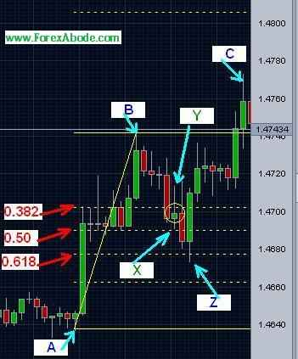

In the above Forex chart, the upward move started from point A. The prices rose to point B and then there was a pullback. Please see the small green candle encircled by the yellow circle. This green candle shows that during this period the price opened between the 38.2% and  50.0% retracement levels and closed also between these two levels. However, during this period the price action went down up to point X which was 50.0% retracement level and went up again to point Y. During the next period, represented by the bigger red candle, it went further down closer to 61.8% retracement level. During the next period which is represented by the bigger green candle, the prices went and crossed 50.0% level and then moved up. It subsequently moved higher towards point “C”.

The above two examples are for retracement to Fibonacci levels during an uptrend. The similar pull back can be seen during downtrends:

### Using Fibonacci Retracement on The Trading Chart

**Downtrend:** Select Fibonacci Retracement tool from the available technical analysis tools and join the Top and Bottom points

**Uptrend:** Select Fibonacci retracement tool and join the bottom and top Points.

The tool automatically draws dotted lines for 0.382, 0.50 and 0.618 or 38.2%, 50% and 61.8% levels

#### Chart:

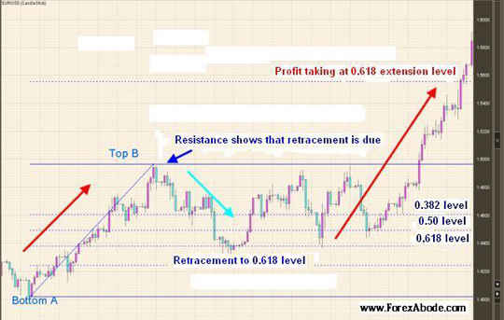

## Unique feature of Fibonacci retracements

We find Fibonacci retracements working as we expect, time and again. What makes them perform so well? Every other technical analysis indicator has dependency on the time-frame. For example one trader may be using daily chart and another a 4-hourly chart. The signals by any other indicators would be different on these charts of different time frames. The uniqueness of Fibonacci retracement levels lie here. If we are considering the overall movement during a trend then they are independent of the time-frame. Fib retracements depend upon the peaks and bottoms of the price-action and whatever is the time-frame of the chart, these highs and lows are absolute and independent of the time-frame

Fibonacci  retracement is the most commonly used tools in technical analysis but you may also like to check other Fibonacci tools like [Fibonacci Arcs](http://www.forexabode.com/technical-analysis/fibonacci-arcs), [Fibonacci Fans](http://www.forexabode.com/technical-analysis/fibonacci-fans) and [Fibonacci Time Zones](http://www.forexabode.com/technical-analysis/fibonacci-time-zones).

You may also use [Fibonacci Pivot Point Calculator](http://www.forexabode.com/trading-tools/pivot-point-calculators/fibonacci-pivot-point-calculator) to calculate Fib pivot points and support and resistance levels.

# Fibonacci Arc

Once we find the high and low points in a chart and join them after selecting the tool “Fibonacci Arcs”s then, with a compass-like movement, three curved lines are drawn at 38.2%, 50% and 61.8%, from the desired point. These lines anticipate the support and resistance levels, and areas of ranging.

The major difference between Fib Retracement analysis and Fibonacci Arcs is as follows:   
  
**Fibonacci Retracement**: Straight lines for retracement levels (0.382, 0.50, 0,618 without considering the time)   
  
**Fibonacci Arcs**: Not straight but curved lines. Means its not only the flat retracement levels but the time is also taken into consideration in Fibonacci Arcs. In simple words Fibonacci retracements are simple mathematical calculation and considers that if the market is moving from 0 to 100 the first retracement will be from 100 to downwards to 61.8 (100-38.2) (Why 38.2: The movement of 100 multiplied by 0.382 = 38.2)   
  
Fibonacci Arcs take into consideration the time i.e. the probability of pulling back to various Fibanacci levels goes down if the market is not able to reach that level for longer time. So while Fibonacci retacement level lines point to the same levels for possible retracements, the Arcs changes the levels (curves up or down)   
  
See the chart in Fig 11 and Fig 12 below for illustrations.

## Fibonacci Arcs Example 1

|  |
| --- |
| Fibonacci Arcs - example 11 |

## Example 2

|  |
| --- |
| Fibonacci Arcs- example 12 |

# Fibonacci Fan

Fibonacci fans are composed of diagonal lines. After the high and low points of the chart are located, and joined. This joining line is then divided into 38.2%, 50% and 61.8%, and lines are drawn from the leftmost point through each of these points. These lines indicate areas of support and resistance. This is again a version of Fibonacci Retracements like **Fibonacci Arcs** where the Retracement levels are not considered as flat levels but breaking the area in angles. Similar to Arcs it takes into account the time i.e. probability of reaching the expected Fibonacci retracement level going low with time. Fibonacci Fans (with other Fibonacci indicators) are shown in figure 13 as follows.

## Fibonacci Arcs and Fibonacci Fans Example

|  |
| --- |
| Fibonacci Arcs and Fans - example 13 |

# Fibonacci Time Zones

Unlike other Fibonacci analysis tools, as mentioned in the main Fibonacci analysis page, and which are for predicting the retracements, Fibonacci time zones are a series of vertical lines. They are composed by dividing a chart into segments with vertical lines spaced apart in increments that conform to the Fibonacci sequence (1, 1, 2, 3, 5, 8, 13 and so on.). These lines indicate areas in which major movement can be expected:

This is just one tool available as an extension of resources but to our best understanding is not used so commonly. Fibonacci Time Zones are shown in figure as follows.

## Example

|  |
| --- |
| Fibonacci Time Zones - example 14 |

# Relative Strength Index (RSI)

## Introduction

Relative Strength Index (RSI) oscillator was developed by J. Welles Wilder

RSI is one of the commonly used momentum indicator (oscillator) for technical analysis. Please note that the following explanation for the usage of Relative Strength Index is focused for Forex trading but the same is equally valid for stocks or any commodity trading.

### How To Trade With RSI?

The signals RSI or Relative Strength Index generates are for overbought and oversold positions. Please note that overbought and oversold situations should only be analyzed when market is running into range and there is no clear trend.

1. RSI Indicator - Overbought situation:RSI suggesting that its time to short sell.
2. RSI - For oversold situation :RSI suggesting that its time to buy.

As mentioned above, please note that RSI (relative strength index) works well when the market moves in range but gives false signals when the market is in trend i.e. Bullish (uptrend) or Bearish (downtrend). You may use ADX for analyzing if the market is in range or has a trend.  
  
RSI readings range from 0 to 100.

* When the RSI nears 30 or goes below 30, the signal is that the currency pair is oversold and it may be the time to buy the pair.
* When RSI nears or crosses 70 and goes below, the signal is that the market is overbought and it may be the time to short sell.

### How to Use RSI?

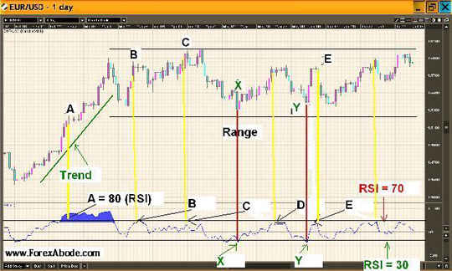

In the above chart for EUR/USD at points A, B, C, D and E the RSI is either close to 70 or over 70. Points B, C, D, E (at the bottom of the chart) are when the market is running in the range (sideways). By range we mean that there is no up or down trend.

The yellow vertical lines are connecting these Relative Strength Index (RSI) levels to the prices on the candlestick chart above.

If you see the corresponding points A, B, C, D, E on the chart (top) you will see that the prices are going down after touching these points. So if would have we short-sold when the prices were at A, B, C, D or E, it would have generated profits as the market went down subsequently.

Similarly the points X, Y (at the bottom) are where the RSI was either nearing level 30 or had gone below the level 30.

The red vertical lines are connecting these RSI levels to the prices on the chart above.

If you notice the corresponding points X and Y on the candle-stick chart (top) you would see that the market bounced back subsequently i.e. gone up after touching these points (points X & Y). So if we bought when the prices were at X or Y, we would have ended with profits as there was an upward move afterwards.

### When to Use?

RSI should be used when there is a sideways movement without a trend.

You may use ADX to see if market is moving sideways (ADX below 25) and then use .

### RSI and ADX:

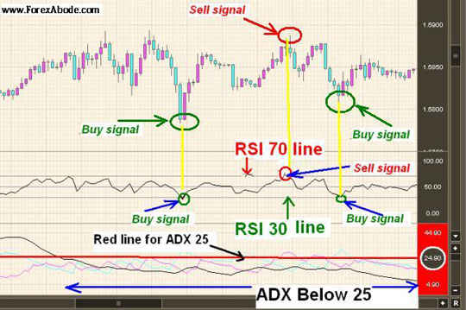

## RSI Trading Strategies

### Cautious approach:

* Buy when RSI goes up the 30 mark, take a small dip again and come below 30 again (as small correction) and then comes back up little over 30. Take profit when the market moves up.
* Sell when RSI goes below 70 mark, takes a correction to go up again and then comes below 70 again.
* Buying and selling at the first crossover/signal is never advisable and we should wait for a correction and reconfirmation.

It is possible that when the RSI is going up, it does not cross or touch the level 70 but starts going down from a level below 70 e.g. from let's say after it reaches the level 65.

Similarly It is possible that when the RSI is going down, it does not cross or touch the level 30 but starts going up from a level above 30 e.g. from let's say after it reaches the level 35.

In such cases we might miss the chance of entering market and if you are ready to take more risk then you can enter the market just below 70 (short-selling), when RSI is going up or just above RSI 30 (buying), when RSI is going down.

## Period setting for Relative Strength Index

The quite preferred setting for the RSI is 14 periods, which means if we were to calculate RSI on a daily chart we would measure 14 days, and in the case of an hourly chart, we would measure 14 hours. The default setting of 14 is common to several popular indicators including [ADX](http://www.forexabode.com/technical-analysis/adx) which has been mentioned in this explanation.

# Average Directional Index (ADX)

Average Directional Index (ADX) is a commonly used technical indicator to measure the strength of the current trend of the price action. Here we will cover the concepts and application of ADX and how it gets complimented by directional components to also know the direction of the trend.

## Introduction

ADX stands for "Average Directional Index". ADX indicator was developed by J. Welles Wilder. ADX helps us in determining if the price action has a trend, either bullish or bearish, of the price action is running in a sideway range. ADX, alone, does not indicate the direction of the trend and just measures the strength of the trend. The indication of the direction comes by two associated components which are known as "**Positive Directional Index**" (+DI) and "**Negative Directional Index"** (-DI).

Please note that the explanation here is focused on Forex trading but the same is equally valid for stocks of any commodity trading.

### Usage

#### Chart 1

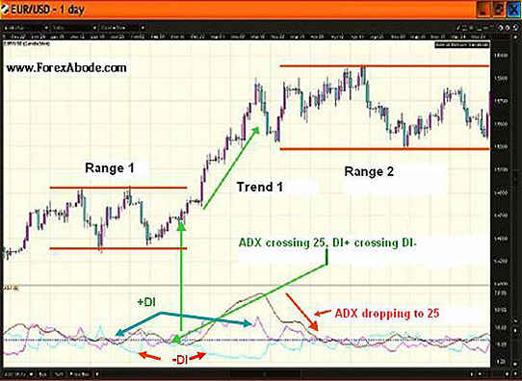

The three crisscrossing lines below the price action chart in the above screenshot represent the ADX indicator. As indicated, one line is the main ADX line and other two are +DI and -DI lines.

ADX is an oscillator which moves between a range of 0 to 100 but it rarely goes above 60. If ADX is above 25, it indicates an underlying trend. Any value below 25 indicates the lack of a trend. A rising ADX represents the rising momentum of the trend and a drop in the value indicates that the momentum of the trend is slowing down.

### Identification of Trend by ADX

|  |  |
| --- | --- |
| **ADX** | **Trend Situation** |
| Above 25 | The market is trending |
| Above 25 and going up | Trend is getting stronger |
| ADX Below 25 | The market is running in range (ranging) |

It is clear from the above table that ADX only indicates the trend strength but not the direction of the trend i.e. if the trend is bullish or bearish.

### Trend Direction Recognition

As mentioned in the table above, the ADX only measures the strength of the trend without hinting about the direction of it. The direction identification is done by the +DI and -DI components.

**Uptrend:** An uptrend is indicated when ADX is above 25 and the +DI line stays over -DI line.

**Downtrend:** A downtrend is indicated when ADX is above 25 and the +DI line stays below -DI line.

### ADX Crossover Signals

The crossover signals for market entry and exit are generated by the +DI and -DI lines' crossover.

1) +DI line moving upwards: When +DI line moves over -DI line, it indicates bullish sentiments and gives an signal for buying or exiting any short position which you might be holding.

2) +DI line moving downwards: When +DI line moves below -DI line, it indicates bearish sentiments and gives an signal for short-selling or to exit any already existing long position.

3) It is always better to consult ADX on longer time-frame charts say before taking a decision on shorter time-frame charts. Longer time-frame charts give us a broader picture of the longer term trend. In simple words the short term chart may indicate that the trend is weakening but a longer term chart may indicate that the drop is just a temporary correction and the trend still exists.

#### Chart 2

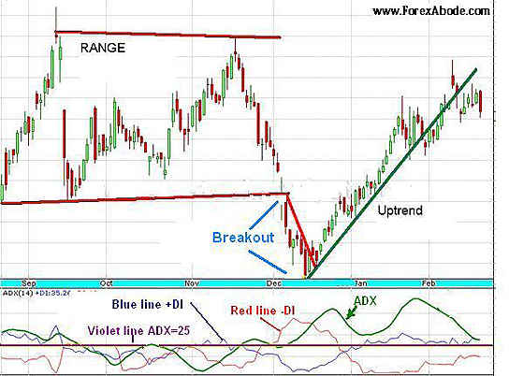

## Formula and Calculation

### Directional Indexes +DI and -DI

We do not need to memorize the following formulas and these are just for ready reference.

The +DI is the percentage of the true range that is up or the range of highs divided by the price range over the last period and previous close, smoothed over a given number of periods.

The -DI is the percentage of the true range that is down or the range of lows divided by the price range over the last day and previous close, smoothed over a given number of periods.

### Step by step calculation

#### The Directional movement

* If "Today's High"  >  "Yesterday's High" then +DM = (Today's High - Yesterday's High)
* If "Today's Low" <  "Yesterday's Low" then -DM = (Yesterday's Low - Today's Low)
* If +DM > -DM then: -DM = 0
* If +DM < -DM then: +DM = 0

#### What is The True Range?

The true range is the largest of any of the following:

(Today's High - Today's Low)

(Today's High - Yesterday's Close)

(Yesterday's Close - Today's Low)

#### The next step is to calculate the moving average of +DM, -DM and the True Range

* +DMMA = [Exponential moving average](http://www.forexabode.com/exponential-moving-average/) of +DM
* -DMMA = Exponential moving average of -DM
* TRMA = Exponential moving average of the True Range

#### Now we calculate the positive and negative Directional Indicators i.e. +DI and -DI

* +DI = +DMMA / TRMA
* -DI = -DMMA / TRMA

#### The next step is to calculate the Directional Index

DX = [(+DI) - (-DI)] / [(+DI) + (-DI)]

What we are doing is dividing the numeric addition of the values of +DI and -DI disregarding the negative sign and dividing it with the difference of the same.

### ADX Formula

The final step is to calculate the [moving average](http://www.forexabode.com/technical-analysis/indicators/moving-averages/) of the calculated DX (directional index), as mentioned above, for a selected number of periods for which we wish to use ADX Hence the Average Directional Movement Index is calculated as follows

ADX = The exponential moving average of DX and hence the formula is as follows:

ADX = SUM[{(+DI)-(-DI)}/{(+DI)+(-DI)}, N]/N

Where:

N = The number of periods used in the calculation e.g. 14 period on a hourly chart means 14 hours and 14 period on a daily chart means 14 days.

### ADX Divergences:

ADX trading signals are also generated or by divergences.

When the subsequent highs and lows (peaks and valleys) of ADX line are going lower than the previous highs and lows, It indicates for an existing or emerging down trend. Similarly if the subsequent highs and lows are going higher than the previous ones, it is an indication that an uptrend is in place or is emerging.

## Period Settings for Average Directional Index

The common period setting for the ADX is 14 periods. On a daily chart 14 period translates into 14 days and on a 4-hourly chart it means previous 14 candles of 4-hours price action.

## Trading with ADX and RSI Combination:

How Success in Forex trading can be achieved by monitoring changing market trends using technical analysis indicators. By using the Average Directional Index ([ADX](http://www.forexabode.com/technical-analysis/adx)) to determine the strength of any tendency to trend, and the Relative Strength Index ([RSI](http://www.forexabode.com/technical-analysis/rsi)) to determine over-sold or over-bought situations, you should be able to identify winning entry and exit points for successful trading.

Forex trading involves dynamically changing markets, and it is of extreme importance that you can determine whether a winning trading position is possible, and that you identify the exact entry and exit points required for success. The Average Directional Index (ADX) should be used to determine the direction the market is taking, and once that has been established then the Relative Strength Index (RSI) can be employed to determine when to buy and when to sell.

The more accurately you are able to identify the entry and exit points, the more successful your Forex trading will become. In view of the accuracy needed to make the correct decisions, it is unlikely to be advisable to base these decisions on just a single technical indicator. Forex markets are so dynamic that trends can change significantly during the life cycle of even a single trade.

Your important trading decisions will be based upon the undernoted trend scenarios:

• A strong trend  
• Trend weakening  
• Trend strengthening  
• Trend moving sideways  
• Trend tending to reversal  
• Trend breaking out from a sideways movement

It is apparent, therefore, that the trend must be identified before you can make a buying or selling decision. The undernoted tools can be used together to enable you to correctly identify the trend situation and also identify an entry and exit position:

ADX above 25 and rising  
If we assume prices closing above the moving average of 5-20 periods for short term and 20-60 periods for medium term trades, then we have a rising moving average with the price action above it - an obvious uptrend. A downtrend situation would be if the price action was below the moving average, because the average would then drop.

Having identified an uptrend, you now have to decide on the entry and exit points, and also levels for take-profit and stop-loss. In order to determine the entry point you could use a number of crossover techniques such as the Moving Average Convergence-Divergence ([MACD](http://www.forexabode.com/technical-analysis/macd)), graphing the difference between 12 and 26 period EMAs (Exponential Moving Averages) over different periods, with an MACD signal line.

However, let's instead look at the RSI that shows you oversold and over bought levels that indicate likely buying and selling levels respectively. Although it unlikely that these will offer accurate results in a strong trending market, knowing the trend will enable you to make a much more informed and intelligent decision. To do that, you will make use of the indicators we have discussed: [Moving Average](http://www.forexabode.com/technical-analysis/moving-averages), ADX and RSI.

To discuss this, you should refer back to the 'possibilities' list above and we shall refer to each in turn.

### 1.  Strong Trend:

Let's consider the situation of an uptrend: ADX over 30 and rising.  The price closes over 20 periods EMA, with the EMA line rising. Assume a strong uptrend, then you will miss the boat for buying if you wait until the RSI gets to 'oversold' before entering. So what should you do?

a)  Entry point: buy when RSI reaches 68-70.  
b)  Exit point: take profit when the ADX level or the RSI drops below 50, or if the price closes at less than the 20 days EMA. These targets should be used only as a guide, since your exit will also depend on a number of other factors such as the market situation or its volatility, and the decision is a dynamic one, not based on one single indicator. You should employ rising take-profit levels and trailing stop-loss situations with strong trends.   
c)  Stop-Loss: employ trailing stop-losses. These are dependent on volatility, and with a volatile price movement the stop-loss should be wide. It can be several pips before the low point of the previous candle of your [candlestic chart](http://www.forexabode.com/technical-analysis/candlestick-chart). The more volatile the market, the more the stop-loss margin because even a continued upturn could still result in an overall closing loss.

### 2.  Trend Becoming Stronger

As 1, above, but with the ADX at 25 and rising.

a)  Entry:  Buy when the RSI drops under 50.   
b)  Exit: Take profit when the ADX either stops rising and/or the RSI drops below 40-42, or the price action dips below the 14 -days EMA at closing. This is an indication only for the same reasons as explained in 1-b above.    
c)  Stop-Loss:  Again, trailing stop-losses. Again, they are dependent on volatility, and widen with increasing volatility. The same considerations apply as with the strong trend re the previous candle's low point: to avoid a potential loss with a very volatile market, the stop-loss should be a few pips above that.

### 3.  Weakening Trend:

The ADX is above 25 but static, while the 20-period [EMA](http://www.forexabode.com/exponential-moving-average) is slowly rising.

a)  Entry:  Buy when the RSI is below 50.  
b)  Exit:  Take profit or exit when the price closes under the 14-day EMA. Again, the comments regarding this being for guidance only apply, together with the need for dynamic decisions in a volatile and indeterminate market.   
c)  Stop-Loss:  As the comments in 1-c and 2-c above.

During a downtrend, a short position can be taken with a dropping EMA and prices are closing below EMAs as opposed to an uptrend, when EMAs are lower than closing prices. Because the ADX in an average directional index, it will not change since it does not indicate direction as such, just the strength of the trend. When RSI goes over the 50 mark, you can take short-position.

These are just a few ways in which technical analysis indicators can be used to help you enter and exit Forex markets at the appropriate times. The same concepts and principles can be used for other trends, the secret to Forex success being perfect timing.

# Parabolic SAR

## Introduction

Parabolic SAR or Parabolic Stop and Reverse indicator was developed by J. Welles Wilder. It is one of the commonly used technical analysis indicators to signal when the trend may be reversing and hence when to stop and reverse the trade position.

This indicator works well when there is a strong uptrend (bullish market) or strong down-trend (bearish market). It does not work well when the market is running sideways i.e. in ranges.

Please note that here our explanation may be focused for technical analysis for Forex trading but the same explanation is equally valid for stocks or any commodity trading using this indicator.

### How To Trade with Parabolic SAR?

When you select this indicator on your trading platform chart, you will see dots above and below the chart. Please see the chart below:

#### ****Parabolic SAR Chart 1****

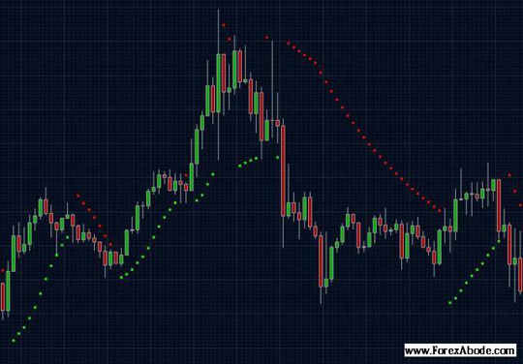

In the forex chart above you will see green dots appearing when prices is moving up and red dots when there is a downward movement. Please note that the default colors for Parabolic SAR indicator on your trading platform’s chart may be different and can be set as per your choice.

The first green dot below the chart appears as an indication of upward movement and then with every upward move subsequent green dots will appear. Similarly the red dot over the chart appears to indicate downward movement and then with every downward move subsequent red dots will appear. The dots in the same direction keep on appearing till a reversal of the trend is confirmed and not before Parabolic SAR confirms the reversal of the trend.

When the market is moving up and you have a long position, follow Parabolic SAR green dots (dots below the chart). When the green dots hit the chart, SAR signals to exit your trade or for entering a trade in reverse position (short-sell), expecting that market may start going down.

When the price is going down and you have a short position (short-sold the pair), follow the red dots (dots above the chart). When the red dots hit the chart, it is a signal to exit the trade or for entering a trade in reverse position (buy the pair), expecting that market may start going up.

Parabolic SAR can also be used for putting trailing stops for your trade i.e. You may consider placing your stop at the levels of appearing dots below the chart when market is moving up and at the dots above the chart when there is a downward move. “Trailing stops” means moving your stop-loss level upwards when the market is moving up and moving your stop-loss level downwards when the market is going down. Using trailing stops in is good as it continuously reduces the risk in trading. This will be explained below.

### Usage

Parabolic SAR can indicate when there is a possibility of a reversal of the trend and hence we can use the signals for stopping and reversing the positions. This indicator can also be used to find the levels to put trailing stops.

### Stopping and Reversing the position

#### Parabolic SAR Chart 2

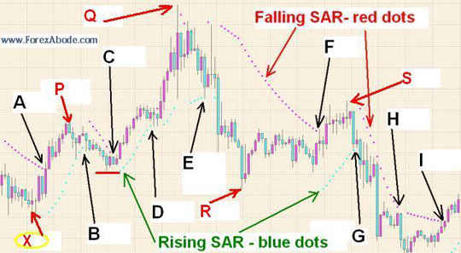

In the chart 2 above, Points A, C, F, H and I are the points where the falling red dots intersected the candlestick chart. The price before these points was going down and had just started going up.

Points B, D, E and G are the points where the rising Parabolic SAR (blue dots) has intersected the chart. The price before these points was going up and had just started going down.

Point A indicates the stop and reversal when, earlier, we might have entered the market for a short position (short-sold), when the market was been bearish. We will not talk about point "A" because the down-trend before point A is not visible in this chart.

Point B: There was a uptrend starting at point X. The market was going up. Suppose we had entered the market for a long position near point X. There was an upward move and we are in for a profitable trade. The movement continued till point P and suddenly it started dropping. We would stay in the trade because the fall might be a short term correction i.e. when the market falls slightly and start moving again. But at point B, the rising Parabolic SAR dots hit the chart. Well, this signaled an exit as it indicates that a reversal in the direction might have taken place. What would have happened if we would not have closed our position at point “B”? The downward move continued up to the small horizontal red line below point “C”. We would have ended up at much less profit if you would not have closed your position at point B.

There can be an argument that the prices have gone up again after falling to the horizontal small red line. But then its always better to play safer in trading as cutting the losses is equally important as making profits.

Suppose at point “B” we come out from the long position and reverse take another short position i.e. we short sell to make a profit if it falls further. Well, at point “C” the falling SAR line (red dots) intersected the chart. This point “C” signaled a “Stop and reversal” again. In such situation we come out of our short position by taking a profit and may enter a long (buy) position. If we did that, then we entered another trade as the market started moving up after that point. We then come out of this long position at point D. Point “D” did not prove to be a good signal but then playing safe may always be better. After point “D” the price moved up again and next signal to come out was at point E. If we did not come out at either point “D” or “E” then we would have ended up at a loss instead of profit as the there was a fall down to the point R.

You may check all other points in the [candlestick chart](http://www.forexabode.com/technical-analysis/candlestick-chart) in chart 3 to see how those Parabolic SAR trading signals worked.

### Trailing Stops with Parabolic SAR

#### Parabolic SAP chart 3

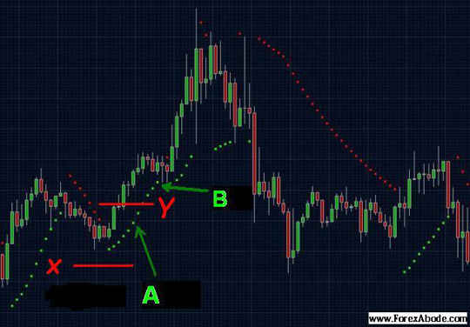

Having trailing stops is one of the very important strategies for profitable trading.

**During uptrend:** Moving stop-loss level upwards from previous levels when the market moves up and we are in long position.

**During downtrend:** Moving stop-loss level downwards from previous levels when there is downward and we are in short position.

In simple words suppose we buy [USD/JPY](http://www.forexabode.com/technical-analysis/usd-jpy) when 1 USD = 100 JPY. We are certain that the price is going to go up. In case the market goes down, instead of going up, we put a stop-loss order at 1 USD = 99.50 JPY.

As per the expectation and analysis, the currency pair (in this case USD/JPY) price start going up. It reaches 1 USD = 100.50 JPY. We are still expecting that the market will still go up further. At this point suppose we move the stop loss order from the previous 1 USD = 99.50 JPY level to 1 USD = 100.10 JPY. Now in case the analysis goes wrong and there is a heavy fall, we still come out with some profit instead of loss.

Parabolic SAR may help in knowing the levels for moving the stops up and down.

We could move the stop positions from one dot to the next dots. In the above forex chart #3, suppose we enter the long position at Point A with a Stop Order at X. The market moves up and we move our stop from X to Y, following SAR green dots (rising SAR), we cut down our chances of losses.

We explained **Parabolic SAR** in the for [technical analysis](http://www.forexabode.com/technical-analysis) in context of **Forex Trading** but the same stands good for stock trading or any commodity trading.

## Trading With Parabolic SAR

In technical analysis Parabolic SAR (Stop and reverse) is one of the more visual indicators. A series of dots are appearing below and above the price action, slopping up with the moving up price action, and slopping down with falling price action. It is in a way following the price upwards and downwards. The change of the trend is indicated when the dots hit the reversing price action. For example with rising prices, the dots also rise and when the price action reverses and starts moving down, the rising dots hit the price action. However, this indication comes with some time lag. And it comes only after the reversal is confirmed. Now if the reversal of the price action is not with a strong trend, the price may soon reverse back to the original direction and the signal may prove to be a false signal.

Parabolic SAR does not indicate the trend or the strength of the trend. Hence we should first confirm the trend and then only follow the signal generated by Parabolic SAR.

Use of Parabolic SAR:

1.  Placing the trailing stop-loss orders and also moving the take-profit levels.   
2.  Closing the position when the SAR indicates the time is appropriate.

However, matters are not as clear-cut as this, so before discussing each of these situations in detail, let's first determine when we should take a signal generated by Parabolic SAR seriously and when we should avoid it.

Rule #1:  Parabolic Stop and Reverse should not be used in sideways market i.e. where there is no clear-cut trend. In such markets the prices tend to change direction quite often and like a pendulum. Therefore, the first step is to confirm whether there is a real trend in the price action or the market is just having a range movement.

For a confirmation of the rend situation we can check one of the following or even a combination:

a)  ADX: ADX should be over 25 and rising.  
b)  A bullish MACD for uptrend and bearish MACD for downtrend, i.e. when the MACD line is crossing and running above the signal line and below it respectively.   
c)  A bullish stochastic (crossing and running over signal line) or bearish stochastic (crossing and running below signal line).

Any of these conditions indicate a definite uptrend or downtrend depending on the sharpness of the crossover and the gaps between the signal line and the indicator line.  Once we have confirmed the trend, we can use Parabolic SAR as follows:

1.  Placing trailing stop-loss orders and moving take-profit levels

When there is an uptrend and we have a long position, we can raise our trailing stop-loss levels upwards from previous levels, and can also raise our take-profit targets at the same time. This should be done while we are also checking the technical as mentioned above to make sure that the uptrend is still there and there are no visible signs of reversal. Similarly with short positions: with a downward trend moving stop-loss levels downwards from previous levels. As long as the other indicators do not indicate any slowing of the trend, then we can also move our take-profit levels downwards. Using trailing stop-loss orders and take-profit targets is very important to maximize the gains. It’s an art which needs to be mastered.

2.  Using the parabolic SAR for stopping and reversing the position

Parabolic SAR can indicate a trend reversal, and so can be used for stopping and reversing positions. When we have a long position during an uptrend, the rising dots will close up to the price action when the trend starts becoming slow, and when the price starts going down - the rising dots will eventually hit the down price. This is an indication by SAR that we might be safest to close the position since the price may likely to continue its downward journey.

However, although we can now close the position and open a short-selling position, we must first check the situation of the trend using other technical indicators as described above, and if a downtrend is not yet confirmed we may stop the long (bought) position but should not enter a short position. In that way we can take profit without committing to another position in opposite side as change in the price action might only be a temporary correction and not reversal.

The same principle applies when we have a short-selling position in bearish market (downtrend). When the price reverses and the falling dots hit the price which started moving up, it indicates that we may close the position to take profit. Again we need to ensure if the this is a possible reversal or just a correction before we enter a buy position.

Summary: Using complementing technical indicators improves the probabilities of better trading decisions. Please also note that normally we should avoid using the combination of competing indicators. By competing indicators we mean the indicators which are for the same purpose but with a different logic. For example Stochastic and MACD. It may not be good to check one indicators reliability with the other indicator.

## MACD, RSI and SAR Combination:

In Forex trading, parabolic Stop and Reverse, or Parabolic SAR for short, is one of the more visual of the technical analysis indicators. A series of dots are shown below and above the price action, rising with rising prices, and falling with falling prices, so indicate an uptrend and a downtrend. However, the series of dots continues in an upward or downward direction until the reversal has been confirmed, and not before, and so the dots will eventually hit the price action. It is then that you should stop the trade and take a position, stop and reverse.

There is a problem with this, however, and it is that Parabolic SAR does not indicate the trend, and so we cannot take a buy position when the dots are below the price action.  However it can be used for:

1.  Placing the trailing stop-loss orders and also moving the take-profit levels.   
2.  Closing the position when the SAR indicates the time is appropriate.

However, matters are not as clear-cut as this, so before discussing each of these situations in detail, let's first determine when the Parabolic SAR indicator is appropriate and when it is not.

First Rule:  [Parabolic SAR](http://www.forexabode.com/technical-analysis/sar) offers relevant analysis of trends, but is not appropriate to a sideways movement of price. Therefore, in order to determine whether the trend analysis is valid, you must confirm whether or not the situation is truly a trend.

To confirm the trend you must use Forex technical analysis, and one or more of the undernoted situations must apply:

a)  ADX: ADX should be over 25 and rising.  
b)  A bullish MACD for uptrend and bearish [MACD](http://www.forexabode.com/technical-analysis/macd) for downtrend, i.e. when the MACD line is crossing above the signal line and below it respectively.   
c)  A bullish [stochastic](http://www.forexabode.com/technical-analysis/stochastic) (crossing over signal line) or bearish stochastic (crossing below signal line).

Any of these conditions indicate a definite uptrend or downtrend.  That being confirmed, we can now confidently use the parabolic SAR as below:

1.  Putting trailing stop-loss orders and moving take-profit levels

When the market is moving upwards and you have a long position, you can raise your trailing stop-loss levels upwards from previous levels, and can also raise your take-profit targets at the same time. This should be done while you are also checking the three Forex technical analysis indicators above to make sure the trend is maintaining an upwards movement. Similarly with short positions: with a downward trend move stop-loss levels downwards from previous levels. As long as the other indicators do not indicate any slowing of the trend, then you can also move your take-profit levels downwards.

2.  Using the parabolic SAR for stopping and reversing the position

SAR can indicate a trend reversal, and so can be used for stopping and reversing positions. When you have a long position during an uptrend, the rising dots will close up to the price action, and after some correction the action starts going down - the rising dots will eventually hit the down price. This is an indication by SAR that you might be safest to close the position since the price is likely to continue downwards.

However, although you can now close the position and open a short position, you must first check the three indicators above, and if a downtrend is not yet confirmed you should stop the long position but do not reverse. In that way you can take profit without committing when there is still a possibility of another trend reversal.

The same principle applies when you have a short position during a down trend. When the price reverses and the falling dots hit the rising price that is an indicator for you to close the position and take profit. It is important that you also maintain a close eye on any emerging classical [chart patterns](http://www.forexabode.com/technical-analysis/important-chart-patterns) in addition to the above Forex [technical analysis indicators](http://www.forexabode.com/technical-analysis), since they may also be used as clues as to the action to take.

# Bollinger Bands®

Bollinger Bands is one of the very commonly used technical analysis indicators and is quite useful in knowing the levels where the price action may reverse in the ranging markets. Bollinger Bands indicator was developed by John Bollinger and is a registered trademark of him.

## Introduction

Bollinger bands gauges the volatility of the market and compare those with the average prices. It consists of 3 lines or bands. The center band represents the moving average of the price action. The other two bands are on the either side i.e. above the center band and below it. The upper band represents the volatility towards the highs of the price action and the lower band represents the volatility on the lows.

As a simple explanation we can say that the lower and upper bands represent the upper and lower trading ranges

### Chart 1

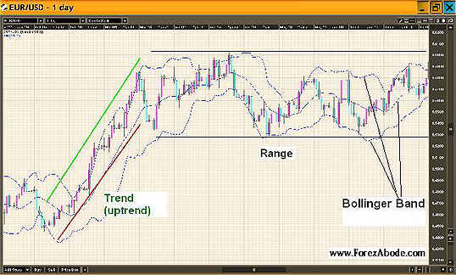

As seen in the above chart for EUR/USD, the Bollinger Bands is a set of three blue dotted lines and look like flowing stream.

At the first glance it would seem as if when the price action touches the upper band, it tends to move down towards the lower band and vice versa. This is how the Bollinger Bands are used to predict when to enter and when to exit a tread position. But please note that these buying and  selling trading signals are only good when the price action is in range i.e. running sideways and not trending in one direction.

### Calculation

The upper and lower bands are based on the calculation of standard deviation.

Let's assume that we are working on Bollinger bands based on 14 periods then the calculation will be as follows:

* Middle Band = Simple moving average for 14 periods.
* Upper Band = Middle band + (2 x standard deviations for 14 periods).
* Lower Band = Middle band – (2 x standard deviations for 14 periods).

#### Calculation for standard deviation

Let's assume that we are working with Bollinger bands for 14 periods then the standard deviation will be calculated as follows:

1. Calculate the simple moving average for 14 periods.
2. Calculate the deviation for each 14 periods. Deviation for a period =. closing price for that period - simple moving average for 14 periods. The value we get will be positive if the closing price is more than the moving average and negative if the closing price is less than the moving average.
3. Square the deviation of each period. By squaring any negative values will become positive.
4. Add all the squared deviations for the 14 periods. Say the sum = D.
5. Divide the sum of the squared deviation by the number of periods i.e. D/14. Basically what we have done is calculated the average of the squared deviations for all the periods. Let's say (D/14) = N
6. Calculate the square root of the above i.e. square root of (D/14). This is the standard deviation for the 14 periods.
7. If we analyze this calculation we would observe that we had take the square of all the values and then at the end we had calculated the square root, hence the purpose of calculating the squares was just to convert any negative values into positive values. The standard deviation is always a positive value.

### Trading with Bollinger Bands

Bollinger Bands can be used for trading in following ways:

### 1) Sideways price action

When the price action is in range then the price generally moves between the upper and the lower bands. Once the price action hits the upper band, it is an indication that it may move down towards the lower band and vice versa. Please not that this cannot be classified as a signal but just as an indication. During the trends the price may keep hitting the bands and bands would keep slopping upwards or downwards with the uptrend and downtrend respectively.

If we analyze the following chart, it would be clear as to what would have happened if entries or exits were made during the sideways price action (points A,B,C,D) and during the trends e.g. point X and Y.

### Chart 2

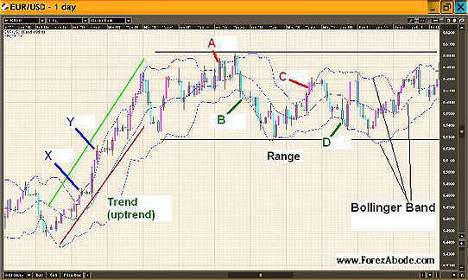

Please refer the above chart for the following points:

1. If we had short sold the pair at A (when price touched Upper band) then we could have made profits by covering the trade when the lower band was touched at B.
2. If we had bought at B (when price touched Lower Band) then we could have made profits by covering the trade when the it touched the Upper Band at C but please note that if we would have entered a long position at point "B" there was a high probability that our position would have met the stop-loss before moving towards the profit target.

### 2) During the Trend

If we short sold EUR/USD at X (when price touched Upper band) and waited for it to touch the lower Band to take profits, we would be in loss as it never went down to touch the lower band. Same with point Y and so on.

Considering the above points it is recommended that that we should not consider the band-hitting as a trading signal as it may prove to be quite risky.

## Trading strategies

#### Conservative but high probability results

1. When the market is moving in range (sideways movement): We can buy when the price touches the lower band or goes outside of the bottom band and close the position when the price touches the moving average i.e. the middle band.
2. When the market is moving in range (sideways movement): We can short sell when the price touches the upper band or goes outside of the upper band and close the position when the price touches the moving average i.e. the middle band.

#### Aggressive Trading Approach:

1. When the market is in range (sideways movement): Buy when the price touches the lower band or goes outside of the bottom band and close the position when the price touches the upper band.
2. When the market is in range (sideways movement): Short sell when the price touches the upper band or goes outside of the upper band and close the position when the price touches the lower band.

### Other Trading Strategies

### Breakout:

When the price action is in a range and the range starts getting narrower, it may be a sign for a break out. The breakout can be on either side and we can enter the market in the direction of the breakout.

### "W" formation

The concept is same as the double bottom chart pattern formation but the following points cover the way it is considered as a signal:

1. During a downtrend the price-action hits the lower band or tries to break below it but gets support.
2. With the above mentioned support, the price retraces towards the middle band or even above it, however, it fails to touch the upper band and falls.
3. The fall takes the price to a level lower than the previous low, however, the price-action fails to touch the lower band and moves up again. Please note that any brief spike may be there which may touch the lower band but such spikes are only considered as market noises and are ignored.
4. Price moves up and breaks above the upper band.

The above pattern indicates a reversal or significant upward consolidation.

### "M" formation

The "M" formation is exactly opposite to the "W" formation and is similar to the double top chart formation and is explained as follows:

1. During an uptrend the price-action hits the upper band or tries to break above it, but finds resistance.
2. With the above mentioned resistance the price retraces towards the middle band or even below it, however, it fails to touch the lower band and jumps up.
3. The upward jump takes the price action to a level, slightly, higher than the previous high, however, the price-action fails to touch the upper band and moves down again. Please note that any brief spike may be there which may touch the upper band but such spikes are only considered as market noises and are ignored.
4. Price falls again and breaks below the lower band.

The above pattern indicates a reversal or significant downward consolidation.

## Period Settings for Bollinger Bands

The quite preferred setting for the Bollinger Bands indicator is 14 periods, which means if we were to calculate on a daily chart we would measure 14 days, and in the case of an hourly chart, we would measure 14 hours. When we apply Bollinger bands on our trading chart the settings would show as "Bollinger Bands (14,2)". Here the figure 14 represents the number of periods and 2 represents the multiplication factor for the standard deviation as mentioned under the "Calculation" heading above

We have explained Bollinger Bands  in the context of Forex Trading but the same concepts stand good for stock trading or any commodity trading.

# Stochastic Oscillator

## Introduction

Stochastic Oscillator was developed by George C. Lane in the late 1950s. This is a momentum indicator and used quite commonly for technical analysis. Here we will talk about the concepts behind Stochastic indicator, it's construction and stochastic trading strategies for trading decisions. Please note that the explanation if focused for Forex trading but it is equally valid for stocks or any commodity trading.

### Overview

In a dynamically changing market it is required to know the current price action with respect to the price action pattern in the recent past. Stochastic oscillator helps us in doing that. It compares the current price with the highest and lowest prices during the selected time period and tells us where does the current price lies with reference to the lowest and highest prices.

Why knowing the current value with reference to the highest and lowest levels of the selected time period is important for trading Decisions?:

Its important to know the current market sentiment and trend in trading. Stochastic indicator does not associate directly with the price but with the momentum of the change in the price. It does not track the price action in the absolute terms but follows the rate of change in the prices. It is called an oscillator because it oscillates in a range of 0 to 100.

Let's assume that we are analyzing the price data for past 2 weeks on a daily chart. If the recent daily closing prices are consistently near the highest value of past two weeks, it would indicate bullish sentiments. The opposite will be true i.e. bearish sentiments will be reflected if the recent daily closing is staying near the lowest price of the 2 weeks.

The Stochastic oscillator has two lines. The main line (called %K) and the trigger line (called %D). The main trading signals are generated when the main line crosses the trigger line upwards or downwards. Trading signals are also generated by over bought & over sold situations and divergences which are explained later.

### Crossover Signals

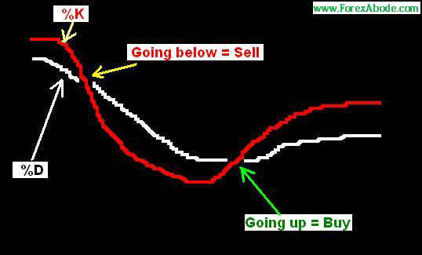

The following chart shows stochastic on a trading platform:

#### Chart 1

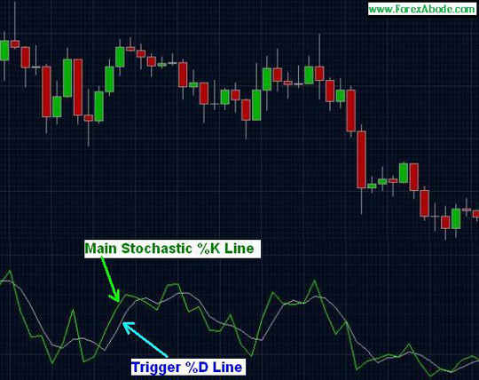

### Calculation and Construction

Let’s see how Stochastic is calculated and what are %K and %D.

The most common setting for Stochastic oscillator is 14 periods. Let's say we are considering daily chart then 1 period would mean 1 day. Let's say that the price action for the previous 14 days was as follows:

|  |  |  |  |
| --- | --- | --- | --- |
| **Time Period** | **High -during the period** | **Low- during the period** | **Closing of the period** |
| 1 | 155.40 | 152.00 | 155.21 |
| 2 | 155.83 | 152.00 | 152.66 |
| 3 | 154.32 | 147.80 | 149.45 |
| 4 | 150.10 | 146.10 | 147.45 |
| 5 | 148.92 | 145.73 | 148.14 |
| 6 | 149.34 | 145.14 | 146.00 |
| 7 | 151.92 | 146.23 | 149.10 |
| 8 | 153.40 | 150.06 | 153.10 |
| 9 | 154.32 | 150.72 | 151.61 |
| 10 | 152.85 | 149.14 | 150.21 |
| 11 | 155.08 | 152.15 | 154.81 |
| 12 | 155.60 | 153.00 | 153.41 |
| 13 | 155.12 | 152.85 | 155.12 |
| 14 | 155.45 | 150.76 | 151.41 |

In the above example the most recent closing is 151.41, the lowest during the 14 days was 145.14 and the highest during the past 14 days was 155.83.

The following formulas show how %K and %D are calculated:

|  |  |  |  |
| --- | --- | --- | --- |
| **%K =** | **100 X (** | **Current Close (n) - Lowest (n)** | **)** |
| **Highest Price (n) - Lowest (n)** |

Here (n) is the selected number of periods, which in our case is 14 periods i.e. 14 days on daily chart. If we are using an hourly chart then 14 periods would mean 14 hours.

|  |  |
| --- | --- |
| **%D** | **3 Period Moving Average of %K** |

Hence considering the price table above % K would be:

|  |  |  |  |
| --- | --- | --- | --- |
| **%k** | **100 X (** | **151.41-145.14** | **) = 58.65%** |
| **155.83 - 145.14** |

#### Summary of %K and %D:

**%K:**  
%K indicates the relative position of current closing with reference to the highest and lowest prices of the selected period of time.

**%D:**  
The %D line is obtained by connecting the SMA ([Simple Moving Average](http://www.forexabode.com/simple-moving-average/)) points of the relative position i.e. %K for previous 3 periods.

Hence what we are checking is where the current relative position i.e. %K stands against it's own [moving average](http://www.forexabode.com/technical-analysis/indicators/moving-averages/) of past 3 days i.e. %D.

#### Further explanation:

Let's try to walk through the explanation in simple points to make it easier to understand. For the following point lets consider the standard period settings which is 14 period and 3 i.e. we are analyzing 14 periods' data for %K and %D is past 3 days' moving average of %K.

1. Stochastic i.e. %D line oscillates between 0 and 100.
2. %D is the simple moving average of past 3 periods of the closing values of %K.
3. If %K is above 50 then it would mean that the current closing prices are staying closer to the highest price of past 14 periods. If it is staying below 50 then it would mean the the current closing prices are near the lowest of 14 periods.
4. If %K line is above %D then it would mean that the recent momentum is positive. On the other hand if %K is staying below %D then it would mean that the recent momentum is negative.
5. When %K and %D lines are in the range of 50 to 100 and %K is over %D line, it indicates that the positive momentum is gaining. In the same range if %K drops below %D line then it would mean that the positive momentum is slowing down or reversing.
6. When %K and %D lines are in the range of 0 to 50 and %K is below %D line, it indicates that the negative momentum is gaining. In the same range if %K moves above %D line then it would mean that the negative  momentum is slowing down or reversing.

### Types of Stochastic Oscillator

There are 3 different types Stochastic oscillator. These types came into existence in order to optimize the frequency of signal generation to avoid false signals. These types are as follows:

1. Fast stochastic
2. [Slow Stochastic](http://www.forexabode.com/technical-analysis/slow-stochastic)
3. [Full Stochastic](http://www.forexabode.com/technical-analysis/full-stochastic)

Out of these 3 types, the one explained on this page is the original stochastic indicator which is also knows as fast. The number of signals generated by it are highest and hence the percentage of false signals or not very good signals is high. The other two types can be seen by clicking on the hyperlinks.

### Trading Signals And Strategies

Stochastic signals can be interpreted in the following ways:

1. Over bought / Over sold situation  
2. Crossover (the Stochastic line crossing the Trigger line)  
3. Divergence

Stochastic indicator is an oscillator. It moves between “0” and “100”.

**Overbought And Oversold situation**

Readings below 20 are considered oversold situation and indicate that it may be the time to buy as the currency pair might have already been oversold. Readings above 80 are considered to be overbought and indicate that it may be the time to short-sell as the currency pair might have already been overbought.

However, level above 80 does not necessarily mean that people will not buy further and a reading below 20 cannot conclude that people will not sell further. The market may continue to rise after the Stochastic Oscillator has reached 80 or crossed over 80 and continue to fall after the Stochastic main line has reached 20 or gone below 20. The overbought and oversold situation are just indications that sooner or later a reversal may come. Taking positions only on the basis that Stochastic has moved over 80 and hence prices would come down or because Stochastic has gone below 20 and hence market would start going up is never a good idea as trends may continue for a long time. Avoid taking actions only based on such observations.

#### Crossover Signals

Bullish and bearish signals are generated when %K moves over or below %D, respectively.

When %K line moves over the %D line, it signals that the upward momentum is increasing and the prices may move up further. Such a crossover gives us a “Buy” signal. Please note that the “Buy” signal by the crossover is more authentic when the Stochastic is near or below 20 (oversold region). Avoid using this “Buy” signal when it is near 80 or above 80 (overbought zone).

When %K line moves below the %D line, it signals that the downward momentum is catching up and prices may move down further. Such a crossover gives us a “Sell” signal. Please note that that the “Sell” signal by the crossover is more authentic when the Stochastic is near or above 80 (overbought zone). Avoid using this “Sell” signal when it is near 20 or below 20 (oversold region).

#### Chart 2

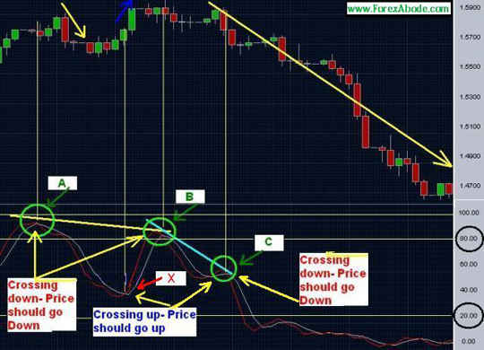

#### Explanation of above Forex chart

The above chart is of EUR/USD with Stochastic oscillator. Let's analyze various situations as follows:

**Point A:** The %K line moves below %D line in the overbought region i.e. when it is in the range of 80 to 100.

The price at point “A” was approx 1.5800 .The prices moved up slightly after this bearish crossover but then, subsequently, went down towards 1.5600. This signal resulted in nearly 200 pips from the crossover point. Please note that after a crossover the price may move in the opposite direction for some time before moving back to the direction pointed out by the signal. Hence it is always advisable to put a limit buy or sell order at few pips below or above, respectively, where the cross over takes place.

#### Point X (corresponding price approximately 1.5700)

Stochastic was near 40 i.e. in the bearish zone but above the oversold region. At point X the %K line moved over the %D line. This signalled an upward movement and that’s what exactly happened. The market moved up approximately 100 pips i.e. from close to 1.5800 to nearly 1.5900.

**Point B:** %K line moved below the %D line. This signal was a bearish signal and though the downward move took place but it was not substantial.

Next crossover at unnamed point after point B: The %K line moved over %D line. This was a bullish signal but it proved to be a false signal. The important point to be noted here is that the Stochastic was around 60 and though it was not in the overbought region but was closer to that region. As mentioned about that a bullish crossover signal near the oversold region is always better.

**Point C:** %K moved below %D line again. Even though the Stochastic main line was not in the overbought region, there was a strong fall. Now if we really ignore the unnamed crossover point between point "B" and point "C" then this strong fall basically relates to the bearish signal at point "B".

A very important point to be noted here is divergence shown by point A, B and C. Divergences may prove to be the best trading signals and will be explained under the next heading.

### Stochastic Oscillator And Divergences

For the most reliable trading signals, wait for a divergence to develop from overbought or oversold levels.

Once the oscillator reaches overbought levels, wait for a negative divergence to develop and also wait for a move below the 80 level. It's better not to sell at the first dip below 80 but wait to see sustains below 80 for some time. Most of the time it would bounce back over 80 after the first dip. The second dip results in the sell signal.

For a buy signal, wait for a positive divergence to develop after the indicator moves above 20. It is better to disregard the first break above 20. After a positive divergence forms, the second break above 20 confirms the divergence and this is a better time to enter a long position.

### Positive And Negative Divergences

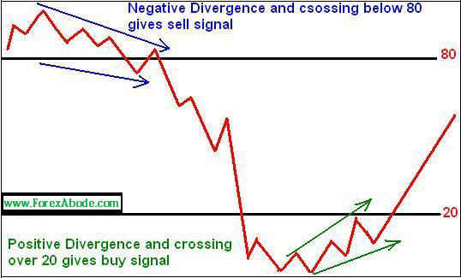

#### Chart 3

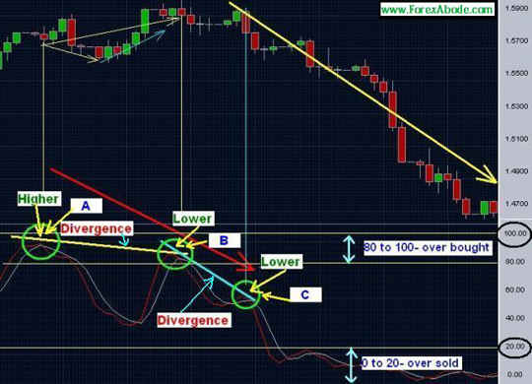

In the above chart point A was closer to the peak in the overbought region. The %K (main line) line went below %D line (trigger line) at point A and then climbed again before going down further from the 2nd bearish crossover at point B. The peak near point B was lower than point A. next peak at point C was lower than peak at Point B. And see what happened. When the %K line crossed %D line downwards near point C, the fall was really strong.

Take a note of such divergences when the subsequent high or low points (peaks and valleys) are going lower than the previous peaks. It may give a good signal for an emerging downtrend. Similarly if the subsequent high and low points (peaks and valleys) are going higher than the previous ones, it may give a good signal for an emerging uptrend.

#### Chart 4

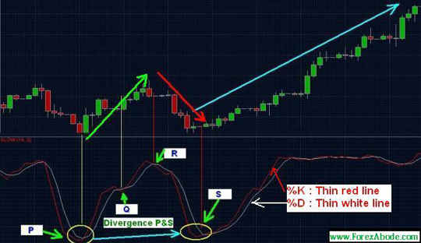

In the chart shown above, please note that after the bullish crossover at point P, the price moved higher as the signal had indicated. Point Q was practically a false signal because the crossover took place neither in the overbought nor in the oversold region. Crossover at point R signalled short selling. The bullish crossover at point S proved to be a very good signal. The price went up very strongly. Note that the lowest point at S was higher than the previous lowest point at P. This was a case of divergence. Hence at point P we got two signals from stochastic oscillator, one from crossover and another by the divergence.

The following chart is for practice by analyzing different crossover scenarios as explained above.

#### Stochastic oscillator - chart 5

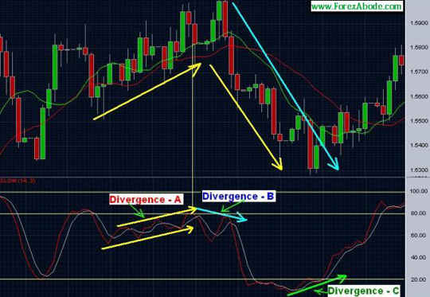

## Bollinger Bands Trading Strategies with ADX, RSI & Stochastic

Bollinger bands can be used with Stochastic and RSI to spot emerging patterns and enable you to take an advantageous trading position. Between these tools, you can take advantage of bearish and bullish patterns as they emerge to decide when to enter and exit specific markets.

Bollinger bands can be excellent indicators of what will happen next in a particular market, and while they generally work best in a sideways market, they can give an excellent indication of when a breakout might take place. It is a common technical indicator that can be used with others to find winning trends.

Bollinger bands close up when the market is stable and widen with increasing volatility. When price movement is sideways, Bollinger bands can be used along with stochastic indicators to indicate good entry points. Because volatility in any market indicates change, and a potentially large move in the market, there are some aspects of Bollinger bands that we should be looking for. Let's see how to interpret Bollinger bands, and also how to use them with other technical tools:

### Widening Bands:

When Bollinger bands widen, the market is becoming more volatile. You should expect that if a price is moving upwards, then it can be expected to continue to increase. However, you must be very clear about the direction the volatility is taking.

### Bollinger Bands Widening (Bullish change)

Bollinger bands tend to widen after a period of tight bands with shorter low volatility candles with some range movement. The upper and lower bands are diverging sharply with an upward price movement and the recent candlesticks are longer than those previously. The action to take is:

a) Check the Relative Strength Index (RSI). Is this at 30 to 50 and rising?   
b) Is the Average Directional Index (ADX) increasing to and over 25 with the +DI crossing the -DI?   
c) Is the 'slow' stochastic line crossing upwards over the signal line?

If each of these is taking place, then you have a 'buy' situation because the price should continue to move upward. You might want to wait for another 2 or 3 candles to establish the trend and then decide to buy, but don't be fooled if there is any slight downward movement - that is likely just a correction, and the trend should continue upwards.

If the ADX does not go over 25 as expected, then perhaps the move upwards is going to be less than hoped for, and while you can still take profit, it will be less than you thought. However, profit should still be there.

### Bollinger Bands Widening - Bearish Change

A bearish change occurs after a similar pattern to a bullish change, the difference being that the price action is moving downwards below the middle. In this case:

a) Check the RSI - is this between 55 and 75 and falling?  
b) Check if the ADX is increasing up to or beyond 25 with the -DI line crossing the +DI line.   
c) Is the Stochastic Line crossing downwards over the signal line?

In this case the move should continue downward, but before taking a short position wait for another 2 or 3 candles to confirm the trend. As before, there might be a short period of correction before the downward trend continues, and perhaps waiting two or three more candles will set your mind at rest that the trend is genuine. However, this might be a limited downward movement if the ADX fails to rise above 25, again leading to lower profits.

### Bollinger Bands Squeeze:

The tighter Bollinger bands become, the less volatile the market. However, because these bands do not remain tight forever, they indicate an opportunity that can be seized if you can predict when they are going to open up again. Bollinger bands squeeze normally indicate an upcoming volatile move like the silence before the storm.

### Bollinger Bands Squeeze - Bullish Change

A bullish change occurs when there is a sideways move with the tightening lower volatility bands associated with short candlesticks. To confirm this change, you should:

a) Make sure there are at least two continuous green bullish candlesticks that are longer than the previous two to three candlesticks.   
b) Check that the RSI is from 30-50 and rising, and perhaps also that the ADX is increasing to 25 or over and that the +DI is crossing -DI.  
c) The stochastic (slow) is crossing upwards over the signal line.

If these are taking place, then you can expect an upward breakout, although you might want to wait for 2-3 more candles to be sure before assuming a buy position with a red candle.

Is ADX moves up below 25, then the upward move might be limited with a corresponding limit to the profit taking.

### Bollinger Bands Tightening - Bearish Change

A bearish change with tightening Bollinger bands takes place under similar conditions to B1 above, only look for:

a) Two continuous red candlesticks that are longer than the previous two to three,  
b) RSI is falling within the range 40 - 60, and the ADX is increasing to 25 or over and -DI is crossing +DI.  
c) The slow slow stochastic is cross downwards over the signal line.

Again wait another 2-3 candles to be sure before you take a sell position, and again there will be a limited profit taking if the ADX fails to move over 25.

### Continuing an Uptrend after Correction During The Ongoing Trend

It is possible for the price to revert to the middle band during an ongoing upward trend, or even to the lower band. If that is the case, then carry out the checks b) and c) as in situation B1 above. If everything is fine, then you can expect the uptrend to continue. Again, before taking a buy position, it will be safer to wait for 2-3 candles for confirmation that the change you noticed was just a correction and that the trend is now continuing upwards.

### Continuing a Downtrend After Correction

As with "continuing uptrend after correction", a temporary reversal can occur during an ongoing downtrend. As above, check the items a), b) and c) in A2 above. If the bearish configuration is still OK, then the downtrend should continue after the brief correction. To be certain, wait another 2-3 candles for confirmation of this, and then take a sell position.

Bollinger bands are very useful in giving you an indication of future trends, particularly when used in conjunction with the stochastic oscillator, and any trend that tends to break out of tightened Bollinger bands will be highly likely to continue that trend, while any trend threatening to break out of widened bands will tend to bounce back to the middle. These are not hard and fast rules, but worth remembering.

# Moving Averages

## Introduction

Moving Averages are used in technical analysis for eliminating market noises or spike i.e. back and forth moves like touch and go in a very short time and insignificant market moves i.e. slight corrective price action to identify the actual trend situation and also the support and resistance levels.

Moving averages and their crossovers signals are very commonly used for trading decisions.

### Moving Averages Explained

In speculative markets the prices change continuously and times there are sudden volatile spikes or insignificant moves against the ongoing trend. These spikes are insignificant as the price action does not sustain in that direction. A sudden drop in price may not necessarily indicate the beginning of a downtrend and in the similar way an upward jump may not necessarily mean the beginning of an uptrend. We need to smoothen out these noises of market to get the real picture of the underlying trends. We can achieve this by averaging out the prices for a decided time period, at every point of time.

### ****What Are Moving Averages?****

Moving average for the selected period of time is the average closing price during that period. If  we are analyzing a daily chart then the simple moving average of 10 periods is going to give us the average of the closing prices of past 10 days. With each passing day the new closing price gets added and the data of the oldest days gets dropped off from the calculation of the moving average. The smoothed line that connects all of these averaging points is the moving average line.

There are various types of moving averages and we shall be talking about those towards the end of this write-up. The trading signals and decisions remain same with all the various types of moving averages but in this explanation we will be using the charts of simple moving average.

#### ****Chart 1:****

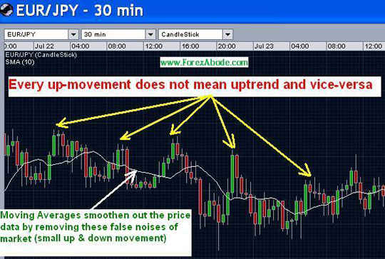

Like most technical indicators, moving averages are trend following and hence lagging indicators. Lagging indicators confirm the trend once the trend has already begun. These indicators  do not predict the future market direction in advance.

### Moving Averages Forecasting

Technical analysts use moving averages very commonly for price action forecasting. The explanation here is focused around Forex trading but the same concepts are applicable for other trading markets:

1. Identification or confirmation of the trend.
2. Identification of possible reversal points of the trends.
3. Gauging the momentum of the trend.
4. Identification of possible support and resistance levels.

### Identification or confirmation of a trend

We can use Moving Averages for the identification or confirmation of a trend. Bullish sentiments or uptrend is indicated when the moving average line is slopping upwards and the price action is continuously above it. Similarly bearish sentiments or uptrend is indicated when the moving average line is slopping downwards and the price action stays below it.

Please note that the above statements are just for initial guidelines because there are other factors and consideration which are important for the determination of a trend situation. The factors are as follows:

1. Time frame of the chart: There may be a short-term uptrend on an hourly chart while there is a longer-term downtrend on the daily or weekly chart. Hence the time-frame of the chart we are analyzing is important.
2. Period setting of the moving average: The price action may be showing bullish or bearish sentiments with reference to a shorter-time period moving average, say 5 periods, but may be indicating a different picture with reference to a moving average of a longer period setting, say 55-day moving average.

Please check the following Forex chart.

#### Chart 2****:****

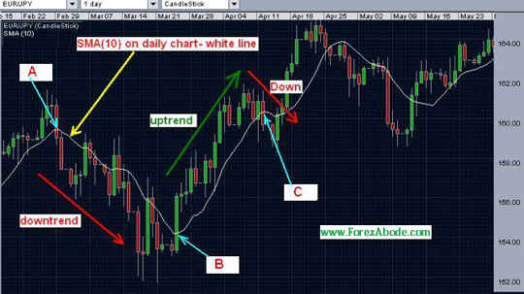

In the above daily chart please check the price action between point "A" and "B". The moving average line between these two points was slopping down and the price action was mainly staying below this line. This was indicating bearish sentiments or bearish trend. Between point B and C the moving average line started slopping upwards with the price action staying above it, and that indicates bullish sentiments or bullish trend.

### Support and Resistance Levels

The above example is also indicating the use of the moving averages as resistance and support levels. Between point "A" and "B" the resistance was coming near the moving average and between the point "B" and "C" the same moving average line turned into a support line.

Please note that the period setting of the moving average is again important. In some situation you may see that a 5-period moving average is acting as support or resistance and in some other situations the support or resistance may be at the moving average of some other period settings. There are no hard and fast rule or science about this as every situation is different and we need to analyze those differently.

### Signal for Reversal of Trend

When the moving average suddenly goes lower than the previous period, it may be a signal that the ongoing uptrend may be ending or a consolidation may be on the way. Similarly when the moving average suddenly goes higher than the previous period, it may mean that the downtrend is ending or a consolidation may be on the way.

Please check the following chart.

#### ****Chart 3:****

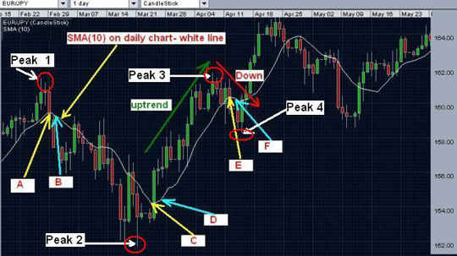

Please take a note of the pair of adjacent points i.e. “A” & “B”, “C” & “D” and “E” & “F” in the chart above with the moving average line in grey color.

1. **The left most part** of the chart before point "A" is showing an upward move. Let's say that the it was an uptrend as daily prices were continuously staying over the upward slopping moving average line. The peak of this uptrend was at the point named as “Peak 1”. Let's assume that we had a long position during that time. Our trade would have given us the maximum profit if we could have closed the position at peak 1. But it is practically impossible to buy at the lowest level and sell at the peak.
2. **Now compare points “A” & “B”** on the SMA line. Till point “A” the SMA line was sloping upwards. During the next period (day in this case as this is daily chart) the point “B” on SMA line is lower than the point “A”. That means the moving average on the next day was lower than that of the previous day. This was an indication that the price-action may reverse the direction or go down for a consolidation. In fact this proved to be a true signal as a downward correction extended after point "B" and the downward move continued for next 15 trading days. Hence at this first indication we should have closed our existing long position.
3. **Points “C” & “D”:** Similar to the example above in point #1, the point marked as "Peak 2" was the lowest point during the downward move. The moving average line changed the direction after that. The moving average at the point "D" had gone higher than what was at point "C". This fact indicated a possible upward correction or even a reversal of the trend.
4. **Points “E” & “F”:** Moving average point “F” went down a bit than that of point "E". This signaled a possible downward correction or even the possibilities of reversal of uptrend. In one way it could be considered as a false signal as the upward gains continued after a slight drop but if we really observe we would see that the signal for downward move (point F lower than point E) was on April 4th and the uptrend resumed around April 17th. Hence, if we would not have closed our position, we would have had almost 2 weeks running into negative with our money stuck up and not usable for entering any other position.

### Moving Averages Technical analysis

Let's see how to use moving averages in technical analysis:

►**Comparing moving averages with actual prices directly:**  
If the price action has been staying on one side of the moving average line and suddenly crossed to the other side then a change in the trend is indicated.

►**Comparing two or more moving averages of different time period for example for period 5\* and period 22\*:**  
A change towards bullish sentiments is indicated if the shorter-term moving average line crosses over the longer-term moving average line. The opposite is true i.e. an emergence of bearish sentiments is indicated when the shorter-term moving average becomes less than the longer term average and hence the short-term moving average line goes below the longer-term moving average line.

## Moving Averages Crossover

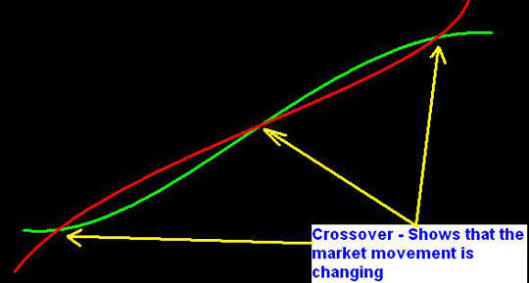

### Crossover of Moving Averages and Price Action

As mentioned above that is the price action has been continuously below the moving average line and then break over this then a bullish or buy signal is generated. The opposite of it would be a bearish or sell signal which is when the price action moves below the moving average line after being above it for an extended period of time.

Please note that the moving average with shorter period setting would generate higher number of signals and the number of false signals would be more. We would recommend to use 5-period, 22-period and 55-period moving averages. On a daily chart the 5 period represents 5 days and hence a trading week, the 22 day represent a trading month. 55-day moving average and 200 day moving averages are commonly used in the technical analysis.

It is always better to wait for some time to see if the price action is sustaining the crossover than to take a position immediately after the crossover.

### Double Crossover Method

In double crossover method we use moving averages of two different time periods.

When the short-term moving average crosses over the longer-term moving average, it is an indication that the recent price action is moving upwards. This crossover can be considered as a bullish signal.

When the short-term moving average moves below the longer-term moving average, it is an indication that the recent price action is moving downwards. This crossover can be considered as a bearish signal.

Please check the following to see the double crossover signals:

#### ****Chart 4:****

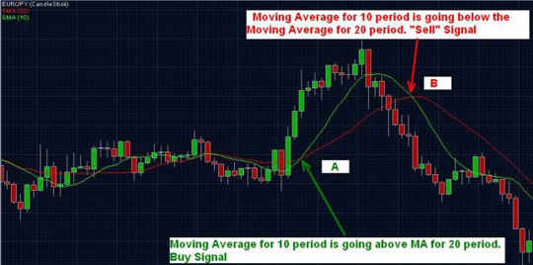

The green line is for the moving average for 10 periods and the red one is for 20 periods 2. At the point “A” the line for 10 periods has crossed the line for the 20 periods 20 and moved up. This gave a bullish signal. The signal proved to be true as there was strong upward move thereafter.

At the point "B" the moving average line for 10 periods went below the line for 20 periods. This indicated that the upward move has lost the momentum and we can expect some downward correction or a reversal of the trend.

Please also note the frequent crossovers on the left hand side when the price action was in a very narrow range. Crossovers during that time were false signals. This also highlights the point that till a real breakout of a narrow range takes place, crossover signals cannot be trusted.

### The Triple Crossover Method

As the name suggests, here we use three moving averages for different time periods. This method provides fewer but more surer signals. While we say surer signals, we may also compromise some good signals because we wait for too long for a reconfirmation. Another fact which goes against this method that if the trend is weak in the momentum, by the time the second crossover takes place, the price may already be on the verge of peaking.

Please see the following Forex chart for a visual explanation.

#### ****Chart 5:****

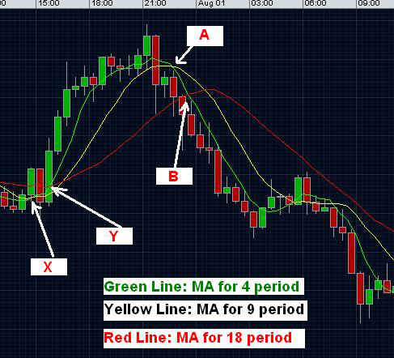

In the chart we have used three moving averages, one for 4 periods (green line), second for 9 periods (white line) and third for 18 periods (red line). In this method we take a trading action when the line for the shortest period crosses both the other moving average lines.

At point “A” the moving average (4) crossed the line for period 9 and gone below. This could be a signal for further downward move and we could have gone for a short-selling position. But we waited till point “B” when this line i.e. for period 4 also crossed the moving average for 18 periods and went below it. Here i.e. at point "B" we entered the short position. The second crossover was for the confirmation of the fall.

Similarly we did not enter a long position at point “X” when the moving average for 4 periods moved over the moving average for 9 periods. We waited till point “Y” when this line ( period 4) also crossed the line for period 18. This increased the probability of the signal being true.

In the above example we used the periods 4, 9 and 18 but that was just to explain the concept and not as strategy. In different kinds of market movements and volatility situations we need to work out with different combinations. One of our favorite combinations is to use period 5, 22 and 55.

**Note:** Please note that the concept of crossover signals does not depend on the type of the moving averages but remains same for all the types.

## Types Of Moving Averages

We have detailed explanations of different types of moving averages on separate pages but the overview the common moving averages is as follows:

#### 1) Simple Moving Average (SMA)

The [Simple Moving Average](http://www.forexabode.com/simple-moving-average/) (SMA) uses the arithmetic mean of a given set of values. If we use SMA of period 10 on a daily chart that would mean the average of the closing prices for each day for past 10 days. The average is 'moving' as when new data comes in the oldest data would be replaced by the new value.

The drawback of SMA is that the weight or importance given to the oldest data is same as the newest. Logically with a moving average the recent data should be given more importance as it may be indicating a new emerging trend.

#### 2) Linearly Weighted Moving Average (WMA)

The linearly weighted moving average (WMA) gives more weight to more recent data. For example, using a day 10 moving average the 10th day would be multiplied by 10, the 9th day by 9 and so on. So the importance or weight for the most recent data point of 10th day will be 10 and the data prior to that will have a weight or importance factor of 9 and so on. This makes WMA more sensitive to the more recent price movement.

Read about [Weighted Moving Average](http://www.forexabode.com/weighted-moving-average/).

#### 3) Exponential Moving Average (EMA)

In technical analysis the EMA is more popular that SMA and WMA.

Let’s see how EMA is different from WMA:

"Linear growth" means that the original value increases by a set amount. "Exponential growth" means that the original value increases by a set percentage. Read about [Exponential Moving Average](http://www.forexabode.com/exponential-moving-average)

For a visual explanation please see the figures below.

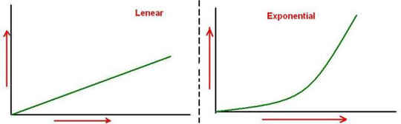

Hence unlike WMA, in which the weight is reduced linearly for older data, in EMA the weight is reduced exponentially or by percentage i.e. more recent data has much more weight and older data has much less percentage weight.

# Ichimoku Cloud

The Ichimoku Cloud can be considered as the foundation stone of technical analysis indicators and is a quite powerful indicator. It was developed in Japan and known as Ichimoku Kinko Hyo (一目均衡表) in Japanese. The Ichimoku not only provides trading signals but also tells us about the strengths of the signals and support and resistance levels. It also helps us in identifying the underlying trends and indicating the momentum of the trends.

## Introduction

Though the Ichimoku Cloud is a versatile indicator, it is often ignored by many beginners. The reason is that at first glance, it may seem very complicated because of its large number of components. The truth is that the Ichimoku is as simple as it is powerful.

We will try to explain the cloud in a simple manner. It would be better if the focus remains on familiarizing oneself with the names of the components and how to use them rather than just going into the details of the formulas and their construction aspects.

Before we start, we wish to mention that the Ichimoku Cloud works better on longer time frame charts (i.e., daily or weekly charts) and should be avoided on shorter time frame charts.

### Look And Feel

#### Ichimoku Chart 1

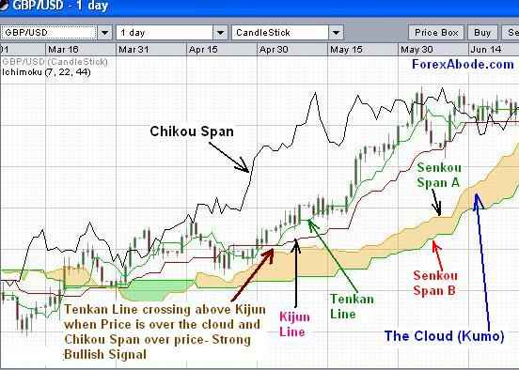

The above chart illustrates the Ichimoku Kinko Hyo on a trading platform. Please check the [Ichimoku Cloud construction](http://www.forexabode.com/images/ichimoku%20cloud%20big.jpg" \t "_blank)  for a bigger picture of the construction of the Ichimoku Cloud.

## Components and Construction

Before we go further, please note that at first glance, the construction of the Ichimoku Cloud may seem complex. But in fact, people who have been using the crossover method of [moving averages](http://www.forexabode.com/technical-analysis/indicators/moving-averages/), or [MACD](http://www.forexabode.com/technical-analysis/indicators/macd/), find that the cloud works in a similar way. The beauty of this indicator is that it serves the purpose of a combination of indicators to identify trends as well as to generate trading signals—hence the name Ichimoku, which means “one glance.” It tells us a lot in just one glance.

The Ichimoku Cloud consists of five lines. Out of these, two lines called Senkou Span A and Senkou Span B make the main cloud (kumo in Japanese). The other three are known as the Tenkan Line, the Kijun Line, and the Chikou Span. Hence, the components are as follows:

1. Cloud or Kumo: made by Senkou Span A and Senkou Span B line.
2. Tenkan Sen (Tenkan Line)
3. Kijun Sen (Kijun Line)
4. Chikou Span

### Calculation

Please note that the formulas below are just for reference, and it’s not required to memorize these.

* Tenkan Line (Conversion Line): (highest high + lowest low)/2 calculated over last 9 periods.
* Kijun Line (Base Line): (highest high + lowest low)/2 calculated over last 26 periods.
* Chikou Span (Lagging Span): most current closing price plotted 26 time periods back.
* Senkou Span A (Leading Span A): (Tenkan Line + Kijun Line)/2 plotted 26 time periods ahead.
* Senkou Span B (Leading Span A): (highest high + lowest low)/2 calculated over past 52 time periods and, sent 26 periods ahead.

Please note that the above explanation is for the Ichimoku Cloud with settings of 9, 26, and 55. These were the original settings when a trading week used to be a six-day week. Nowadays, the settings of 7, 22, and 44 are used. Hence, the above calculation will use 7, 22, and 44 periods instead of 9, 26, and 52 periods. The topic is covered toward the end under the section “Period Settings.” A period will equal a day if you are using a daily chart and a week if you are using a weekly chart.

#### Ichimoku Chart 2:

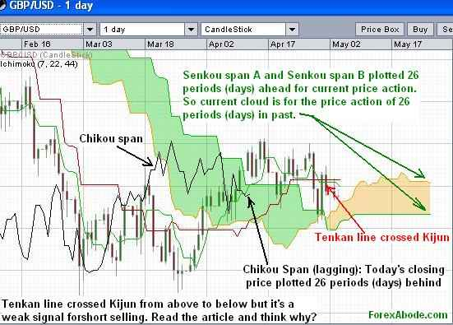

## Ichimoku Cloud Trading Signals and Analysis

### Resistance and Support Levels

#### First level of resistance or support

The main resistance and support levels can be derived from the Tenkan Sen, the Kijun Sen, and the upper and lower edges of the main cloud. These levels indicate either the support level or the resistance level depending on the position of the price action.

#### Second level of resistance or support

The second level of resistance or support is the Kijun Line. When the price action breaks below the Tenkan Line during an upward move, then the Kijun Line becomes the second level of support. Similarly, when the price action breaks above the Tenkan Line during a downtrend, then the Kijun Line becomes the second level of resistance.

#### Third and forth levels of resistance or support

The third and fourth levels of resistance or support are either the upper edge or the lower edge of the cloud. When the price action is above the cloud during an uptrend and both the first and second levels of support of the Tenkan Line and the Kijun Line are broken, then the upper edge and the lower edge of the cloud become the third and fourth levels of support, respectively.

Similarly, during a downtrend, when the price is below the cloud and breaks above the resistance of the Tenkan Line and the Kijun Line, then the lower edge and the upper edge of the cloud become the third and fourth levels of resistance, respectively.

### Market Trend Identification:

The Ichimoku can be used to identify and analyze underlying trends,  that is, if a trend exists. The Ichimoku Cloud not only tells us about the existence of a trend but also indicates the strength of the trend. The trend can be identified as follows:

### Position of the price action with respect to the cloud

1. When prices are closing below the Ichimoku Cloud, it means a bearish trend or a downtrend.
2. When the prices are closing over the cloud, it means a bullish trend or an uptrend.
3. When the price action is inside the cloud, it means a range or a sideways movement.

### Position of the price action with respect to various support and resistance levels

The resistance and support levels are derived from the Tenkan Line, the Kijun Line, the upper edge of the cloud, and the lower edge of the cloud. These levels act as support when the price action is above these levels, and the same levels become resistance when the price action is below these levels.

#### Strong Uptrend

A strong uptrend is indicated when the price is above the cloud and continuously stays above the first level of support of the Tenkan Line.

#### Strong downtrend

A strong downtrend is indicated when the price is below the cloud and continuously stays below the first level of resistance of the Tenkan Line.

### Position of the Chikou Span with respect to the cloud

1. Downward (bearish) pressure if the Chikou Span remains below the current price action
2. Upward (bullish) force if the Chikou Span remains above the current price action

### Buy and Sell Trading Signals

The trading signals given by the cloud are of two kinds:

1. Crossover signals
2. Non-crossover signals

### Ichimoku Crossover signals

These signals are generated by the crossover of the Tenkan Line and the Kijun Line. Similar to the strength of the trend, the Ichimoku signals also tell us whether the signal is strong or weak.

1. The Tenkan Line crossing above the Kijun Line means a bullish buy signal for a long position.
2. The Tenkan Line moving below the Kijun Line indicates a bearish (sell) signal for a short-selling trade.

The beauty of this indicator is that it can tell us the strengths of the signals in one glance if we take the different components into consideration.

#### Points to be observed:

1. Has the crossover of the Tenkan Line and the Kijun Line taken place above the cloud, below the cloud, or within the cloud?
2. Where was the price action at the time of the crossover? Above the cloud (kumo), below the cloud, or within the cloud?
3. Where was the Chikou Span at the time of the crossover? Above the cloud (kumo), below the cloud, or within the cloud?

#### Strong Bullish Trading Signals:

1. The Tenkan Line moves above the Kijun Line.
2. At the time of the crossover, the price action is above the cloud.
3. At the time of the crossover, the Chikou Span is above the cloud.
4. The crossover takes place above the cloud.

#### Medium Strength Bullish Signals

1. The Tenkan Line moves above the Kijun Line.
2. At the time of the crossover, the price action is above the cloud.
3. At the time of the crossover, the Chikou Span is above the cloud.
4. The crossover takes place within the cloud.

#### Weak Bullish Trading Signal

If the combination is not as mentioned above, then the signal is to be considered as weak and should be ignored.

Examples:

1. The Tenkan Line moves above the Kijun Line.
2. At the time of the crossover, the price action is NOT above the cloud.
3. At the time of the crossover, the Chikou Span is NOT above the cloud.
4. The crossover takes place below the cloud.

#### Ichimoku Chart 3



#### Strong Bearish Signals

1. The Tenkan Line moves below the Kijun Line.
2. At the time of the crossover, the price action is below the cloud.
3. At the time of the crossover, the Chikou Span is below the cloud.
4. The crossover takes place below the cloud.

#### Medium Strength Bearish Signals

1. The Tenkan Line moves below the Kijun Line.
2. At the time of the crossover, the price action is NOT below the cloud.
3. At the time of the crossover, the Chikou Span is NOT below the cloud.
4. The crossover takes place within the cloud.

#### Weak Buy Trading Signal

If the combination is not as mentioned above, then the signal is to be considered as weak and should be ignored.

Examples:

1. The Tenkan Line moves below the Kijun Line.
2. At the time of the crossover, the price action is NOT below the cloud.
3. At the time of the crossover, the Chikou Span is NOT below the cloud.
4. The crossover takes place above the cloud.

#### Ichimoku Chart 4

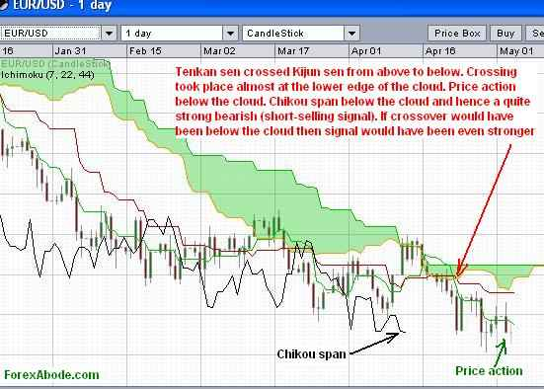

### Non-crossover signals

These signals are generated when during a strong trend there is a consolidation and the price hits the support or resistance levels. For example during a strong uptrend if there is a correction and price hits the support level, it would indicate that we may take a long position with the anticipation that the price will get support and will move up again.

### History

The Ichimoku Kinko Hyo indicator was developed before World War II by Tokyo newspaper journalist Goichi Hosoda with the help of some of his colleagues.

## Period settings for Ichimoku cloud

The standard period setting for the Ichimoku Cloud is 9, 26, and 52. This translates into 1.5 weeks, one month, and two months considering a six-day workweek in those days in Japan. Many traders tend to change it to 7, 22, and 44 considering the five-day workweek, but the old standard settings of 9, 26, and 52 give good results as many traders still make decisions with these period settings.

## Japanese terms related to Ichimoku cloud (一目均衡表)

Ichimoku: Ichi in Japanese is one (1). Ichimoku means “One glance”  
Kinko = balance  
Hyo = Chart  
Ichimoku Kino Hyo = Balanced (equilibrium) chart at a glance  
Sen = Line  
Tenkan Sen = Conversion line  
Kijun-Sen = Base line  
Senkou-span A = Leading span 1  
Senkou-span B = Leading span 2  
Chikou = Lagging span  
Kumo = Cloud

# Candlestick Charts

Words and Expression: Figures are like words. Thousands of word spoken may make them difficult to comprehend. Charting those figures is like expressions. A visual way to understand and grasp the movement in a more efficient way

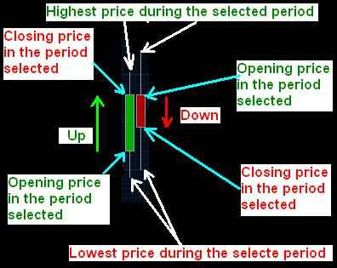

Candlestick charting was developed as an effort to add market sentiments to the normal charts and to enhance the understanding of the market movement even more.

Market prices are not only governed by the facts. The market is not ONLY governed by the fundamentals or technicals (technical analysis). There is this third factor and which plays a very important role. This is market psychology or the general market sentiment. The market may go upside down in one day or even in one hour… but if you would really see, no economic fundamentals would have changed during that day or that hour. What really changed was the market sentiment. It’s Fear and Greed but many times just simple fear. Candlestick charts can give an understanding of those market sentiments.

It’s believed that Candlestick charts were developed in the 18th century by famous Japanese rice trader Homma Munehisa. The basic idea behind candlestick charting was to have an overview of open, high, low, and close market prices over a certain period. Candlestick charts make it very easy to read and understand the market sentiments hidden behind the price movement in trading be it Forex Trading or any stock and commodity trading. Since the conception there people have been putting great efforts to relate specific chart patterns to the likely future behavior of a market.

Around 1900 Charles Dow had picked up the candlestick charting and since then it has been commonly used by financial instruments’ traders. In this article we will mainly be talking in terms of Forex (currency) trading.

## ****Best Candlestick chart Patterns****

There are many candlestick patterns but we will be talking about the important ones.

Please also note that these patterns must be combined with other technical analysis indicators and not in isolation.

The following patterns are divided into two parts: Bullish patterns and bearish patterns. These are reversal patterns that show up after a downtrend or pullback (bullish patterns) or an uptrend (bearish patterns).

### Bullish Candlestick Chart Patterns

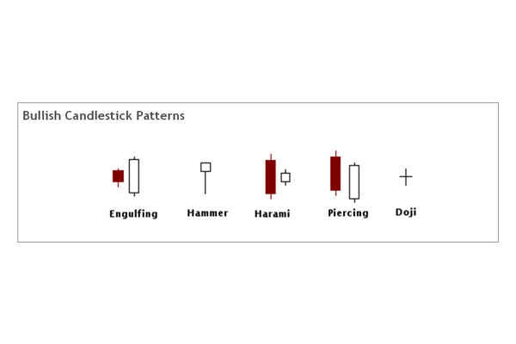

**Candlestick Engulfing Pattern:** A commonly observed and popular favorite candlestick pattern. Engulfing pattern consists of two candles. The first (red candle) is a narrow range candle that closes down for the period near the low of that period ("Day" on a "daily chart" or "Hour" on an "hourly chart"). The sellers currency pair is being sold and have a downward pressure but the narrow candle indicates that the downward pressure is not aggressive. The second period candle is a wide range (long) candle that “engulfs” the body of the first candle and closes over the top of the range. The currency pair is being bought more aggressively.

**Candlestick Hammer Pattern:** The rice of the currency pair opened for a particular period ("Day" on a "daily chart" or "Hour" on an "hourly chart"), then at some point there was a aggressive selling pressure and the price of the currency pair shot down. By the end of the period (closing), the downward pressure decreased and buying started and the price of the currency pair closed much above the low of that period.

**Candlestick Harami Pattern:** When you see this pattern the first thing that comes to mind is that the momentum preceding it has stopped. During the first period ("Day" on a "daily chart" or "Hour" on an "hourly chart") you see a wide range candle that closes near low of that period. The currency pair is still being sold. Then during the next period, there is only a narrow range candle that closes up for that period.

**Candlestick Piercing:** This is also a two-candle reversal pattern where on the first day you see a wide range candle that closes near the bottom of the range. The sellers are in control. On the second day you see a wide range candle that has to close at least halfway into the prior candle. Those that shorted the stock on first day are now sitting at a loss on the rally that happens on the second day. This can set up a powerful reversal.

**Candlestick Doji Pattern:** The doji is probably the most popular candlestick pattern. The stock opens up and goes nowhere throughout the day and closes right at or near the opening price. Quite simply, it represents indecision and causes traders to question the current trend. This can often trigger reversals in the opposite direction.

### Bearish Candlestick Patterns

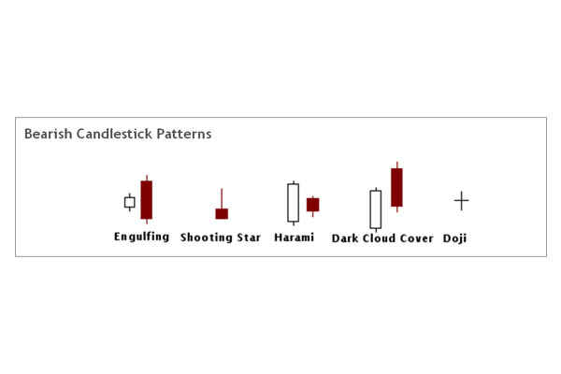

You’ll notice that all of these bearish patterns are the opposite of the bullish patterns. These patterns come after a rally and signify a possible reversal just like the bullish patterns.

Ok, now it’s your turn! I’ll let you figure out what is happening in each of the patterns above to cause these to be considered bearish. Look at each candle and try to get into the minds of the traders involved in the candle.

## ****Kickers****

There is one more pattern worthy of mention. A "kicker" is sometimes referred to as the most powerful candlestick pattern of all.

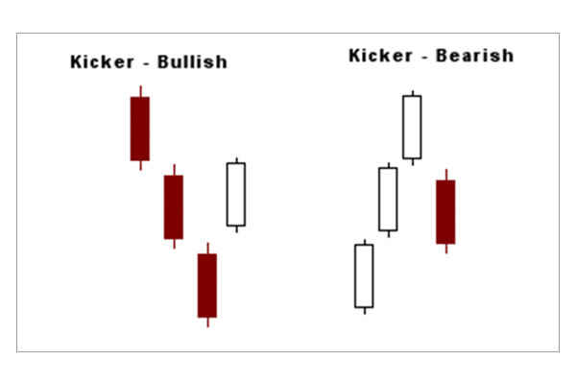

You can see in the above graphic why this pattern is so explosive. Like most candle patterns there is a bullish and bearish version. In the bullish version, the stock is moving down and the last red candle closes at the bottom of the range.

Then, on the next day, the stock gaps open above the previous days high and close. This "shock event" forces short sellers to cover and brings in new traders on the long side.

This is reversed in the bearish version.

# Point & Figure Charts

Charting the price action by Point & Figure charts (P&F charts) is a very effective method to know the true picture of the market trend by avoiding the market noises or insignificant moves

In today’s world the information availability is very easy. Be it the fundamental factors which affect the financial market or the actual ongoing price data at every moment. Getting hold of the information is not an issue, what is important is how do we organize the various bits and pieces and process those to analyze the same in a meaningful way.

In speculative trading markets the prices change every moment but every move of the price is not important. here is a lot of movement and insignificant spike in the price-action which can be ignored simply ignored as meaningless. Point & Figure charting helps us in doing that in a very effective way.

## Point & Figure Versus Other Charting methods

Charts represent the statistical data in a visual form to make the interpretation easy. The initial charting methods like "Line charts" do this representation literally. Financial charts then evolved to bar charts and candlestick charts to put the pricing information in a more meaningful way. Point and Figure charting is another big jump in that direction.

While other charts e.g. bar charts and candlestick charts record every move of the market on a time scale, the soul of the P&F chart is pure price action and nothing else. Point & Figure charting does not take the time factor, volumes, highs and lows etc into consideration. It is only about the pure price action and that too by avoiding market noises.

In order to avoid to ignore the insignificant price-action, the first step to draw a P&F chart is to decide the moves which can be considered as significant or worth considering.

## Construction of Forex Point & Figure charts

The very first step in drawing the P&F Chart is to decide about the amount of move in the price action which we should consider as significant and hence worth recording. There are two types of significant moves we need to consider, one in the direction of the recent trend and other as reversal. For this purpose first of all we decide about the following components:

### Box Size

Box size is the amount of movement of the price which is worth considering in the direction of the recent trend. In this tutorial we will consider a box size as 10 pips. What it would mean is that if the prices are falling then we will consider a drop of 10 pips or more as a fall but any drop less than 10 pips will be ignored. Similarly if the prices are moving up then any upward move less than 10 pips will be ignored.

In this article we shall consider the box size as 10 Pips.

### Reversal size

Reversal size is the amount of move in the price which we decide as worth recording as a reversal. Please note that reversal does not mean a reversal in the overall trend. Reversal here only means the reversal of the recent price-action direction.

The most commonly used reversal size is equal to three boxes. Hence is we our "Box Size" is 10 pips for a particular currency pair then the "Reversal Size" would be 30 pips.

In this tutorial we shall consider the reversal size as 30 pips (3 boxes).

Point & Figure charts are alternate columns of X’s and O’s. “X” represents an upward move and “O” represents a downward move. Any one column on the chart will have either X’s or O’s i.e. no single column can have both X’s and O’s.

### Step to Step Guide for constructing a Forex Point & Figure Chart

### Time frame

The very first step before drawing P&F chart is to decide the time frame of the chart. In this tutorial we will be using daily chart.

### Price point

The second step is to decide which price points we would be using. There are three important price points for every period, closing price, High and low. Opening price is always the previous period's closing price. Considering this there are two options about the price point and these are as follows:

### 1) Closing price:

We can just record the closing price of the day as we are going to use daily charts. This is the simple and effective way for constructing the point and figure charts.

### 2) High and Low method:

In this method we record either the high or the low points of the day's price-action. The rules for High-Low method are as follows:

### When the prices are moving down and we are drawing the column with O's

* Record the low if it is equal to or more than the "Box Size" than the previously recorded price and ignore the high of the current day.
* Record the high when the low is not having the required Box Size difference with the previously recorded price but the high has the required "Reversal size" (3-box sizes) difference.
* Ignore both when neither the low has the required Box Size difference nor the high has the required "Reversal size" difference.

### When the prices are moving up and we are drawing the column with X's

* Record the high if it is equal to or more than the "Box Size" than the previously recorded price and ignore the low of the current day.
* Record the low when high is not having the required Box Size difference with the previously recorded price but the low has the required "Reversal size" (3-box sizes) difference.
* Ignore both when neither the high has the required Box Size difference nor the low has the required "Reversal size" difference

In this tutorial we will be using the daily closing prices for the explanation.

For our exercise to construct the P&F chart, let's consider that the closing prices of the currency pair in question have been as in the left side of the following:

#### Example of Constructing a Forex P&F Chart

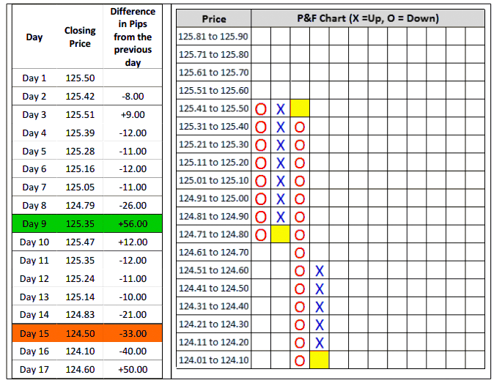

The Point & Figure chart on the right hand side is drawn based on the daily closing prices indicated on the left hand side.

## Step by Step Explanation

1. Please note that on the left hand side of the P&F chart we have used price range of 10 pips e.g. 124.01 to 124 and so on. Each of this range represents a box size of 10 pips.
2. We observe that during the first day the price has been falling and hence in the first column we enter the first "O" for the falling prices in the row 125.41 to 125.50. This entry points to the closing price of the first day i.e. 125.50.
3. The closing prices of Day 2 and Day 3 did not meet the requirement of the box size of 10 pips and hence we ignored those prices and no entries were made.
4. Day 4 had a closing 12 pips below the previous day and was more than the Box size. But what we are interested in is the difference with the previous entry i.e. 125.50. The difference was 11 pips. We enter another "O" for the fall below the previous "O".
5. Days 5, 6 and 7 resulted in the subsequent O's just one box below the previous ones.
6. Now please note that the Day 8 had a difference of 26 pips which was more than 2 box sizes. The previous "O" was in the row representing 125.01 to 125.10. The "O" for the day 8 would be in the row of 124.71 to 124.80. What it would mean that we have two blank cells in the previous two rows of 124.81 to 124.90 and 124.91 to 125.00. The point to be noted here is that these two cells would also be marked with O's. This is because the price as covered those ranges during the fall.
7. The closing price of day 9 was 56 pips more than the day 8. This reversal was more than the required "reversal size" of 30 pips and hence it requires an X to be market in the next column. This "X" would be entered in the row representing 125.31 to 125.40 as the closing price was 125.35.
8. The important point to be noted is that all the cells below the mentioned cell in point number 8 are also to be marked with "X" as the price action has covered all those prices during the upward move. Another point to be noted is about the lowest cell highlighted by yellow color. This cell is left blank. If you observe the subsequent columns, you will note that the column of X starts from one cell above the bottom of "O column" and the column of O starts from one cell below the top of the previous "X column". This is because the subsequent column are representing a reversal and  entering an X where the O ended or vice versa is not required as that price range has already been taken care of.

### How to decide Box Size And Reversal size

For any Point & Figure chart for Forex we need to consider the following criteria to decide on the box and reversal sizes:

### 1) Volatility

Some currency pairs tend to have more volatility than others. For such highly volatile currency pairs we may need to have a bigger box size. For example GBP/JPY would generally have quite high volatility than many other currency pairs.

### 2) Time frame

If our P&F chart is based on a larger time frame than the box size may also need to be large. The box sizes for a daily P&F chart and a 4-hourly chart will be different. The reason is simple that the total price movement in during a day may be much larger that it would be in any 4-hourly period.

## Using Point & Figure charts

Reading and analyzing Point & Figure charts and taking trading decision are same as any other chart. We use the trend lines and various [common chart patterns](http://www.forexabode.com/technical-analysis/indicators/important-chart-patterns/) for our trading decisions. Most of the trading positions depend on either the breakouts of the chart patterns. The difference is that on other charts the chart patterns represent the price actions directly while in P&F charts the chart patterns eliminate the insignificant price actions or market noises.

Please have a look on the following charts which are self explanatory:

## Example 1 - Break of resistance trend line by P&F

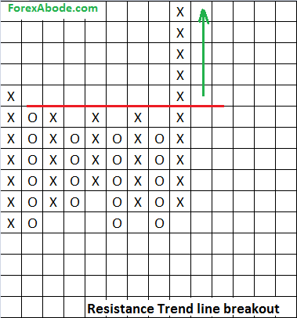

The above chart represents the breakout of the resistance trend line. The price continued to rise after the breakout.

## Example 2 - Break of support trend line by P&F

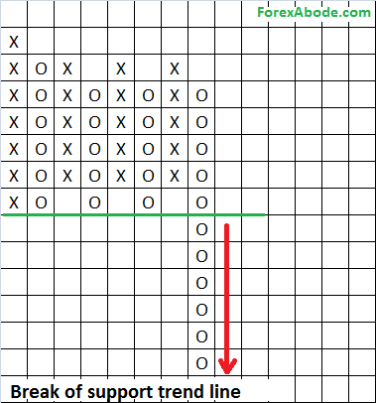

The above chart illustrates the breakout of the support trend line and the fall afterwards.

## Example 3 - Ascending Triangle Breakout by P&F

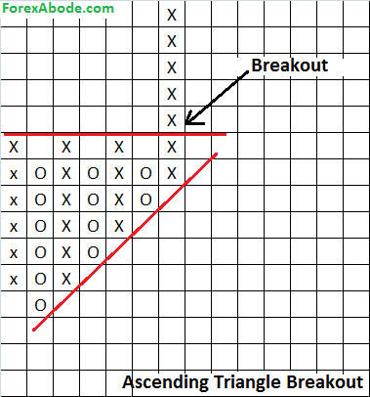

The above example #3 again shows a bullish breakout from an ascending triangle. Please note that the ascending triangles are bullish patterns.

## Example 4 - Break of Descending Triangle by P&F Chart

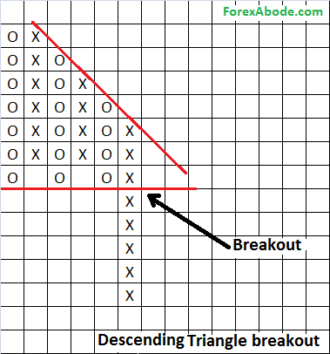

In the above chart a breakout of descending triangle has taken place. Descending triangles are a bearish configuration.  The price action continued to drop after this breakout.

## Example 5 - Double Top Formation on P&F Chart

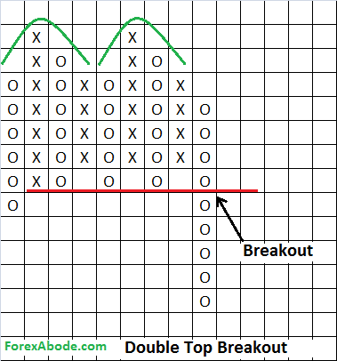

The above chart in example #5 shows a double top formation on Point & Figure chart. This works in the same way as with the normal price action charts.

## Example 6 - P&F Chart and Double Bottom Formation

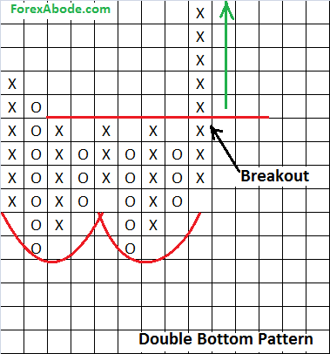

The above chart in example #5 shows a double bottom formation on Point & Figure chart. Just like the double top, the double bottom formation also works as with the normal price action charts.

## Example 7 - Bullish Breakup from Symmetrical Triangle

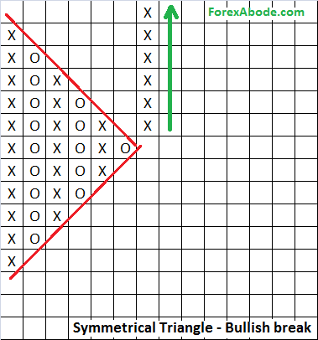

In above P&F chart the trend lines were forming a symmetrical triangle but then the price break out of the upper trend line and continued moving upward.

## Example 8 - P&F Chart's Bearish Breakup from Symmetrical Triangle

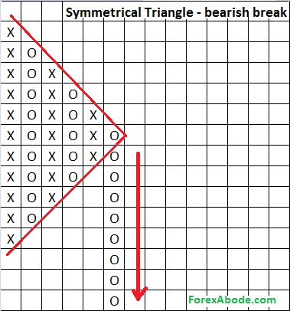

In the above point and figure chart the trend lines were forming a symmetrical triangle but then the price break out of the lower trend line and continued moving downward.

Point and Figure charting can be an important and powerful trading tool if you can invest some time to work on the same.

# Introduction of Forex Chart Patterns

Very often we find certain patterns forming, time and again, on our trading charts. These common patterns are nothing but a reflection of mass psychology and the price action because of that. For example we see the price going up strongly to one level, fails to sustain and falls back. The price action rises again and move to the same level again and falls again to the previous low. Such action is clearly indicating that traders are fearing any price action beyond those peaks. This fear for further gains is also an indication that short-selling may start and the prices may drop even further. This gives us our famous double top chart pattern which is discussed in detail later.

These psychological indications are further fueled because many of the trades may not be going into the depths of this analysis but may be simply taking trading positions by simply following these patterns i.e. by the book. This increases the probability of getting expected results from these patterns.

In a way chart patterns are an extended or more complex version of trend lines. The trend lines are straight lines which represent the support and resistance levels. However the supports and resistance levels may not always follow a straight line and may follow some more complex patterns.

## Chart patterns and psychology

Earlier we had mentioned that the chart patterns are a representation of mass psychology or sentiments. If we go a little deeper we find that these chart formations or patterns are observed during the times of uncertainty or when the price action is lacking a clear direction. Any technical indicator would tend to generate more and more false signals when there is a clear lack of a directional movement. The confusion may be so large that even the price action may not follow any straight trend lines for supports and resistances. Well, the hope is not lost even at such times because if we are watching closely, we may find some or other pattern in the price action which may indicate the underlying sentiments and hence the possible upcoming direction.

Understanding and trading with these important chart patterns can add positively to the trading results. It is always good to keep an eye on the charts of different timeframes to lookout for any common formation taking place.

### Types of chart patterns:

The chart patterns can be classified in two ways, either :

1. Reversal patterns

And

1. Continuation patterns

OR

1. Bullish Patterns

And

1. Bearish Patterns

#### Reversal patterns:

Reversal patterns represent the possibilities of a reversal of the ongoing trend. Reversal patterns may mean a reversal all the time. During a trend there would be frequent consolidations before the price action moves in the direction of the trend, once again. Hence the reversal patterns indicate either a trend reversal or possibilities of deeper consolidations.

#### Continuation patterns:

During strong trends there are occasions when the price action pauses and go into a sideways mode or in an uncertain volatile mode. At such times either it may end up in reversing the direction or continue in the direction of the trend. Continuation patterns indicate that the possibilities of trend continuation are higher.

#### Bullish and bearish chart patterns

As the name suggests, these patterns indicate either the bullish sentiments or the bearish sentiments even when the price action is indicating indecisiveness at the first glance.

#### List of important chart patterns:

* [Double top chart pattern](http://www.forexabode.com/technical-analysis/indicators/chart-patterns/double-top/)
* [Double bottom chart pattern](http://www.forexabode.com/technical-analysis/indicators/chart-patterns/double-bottom/)
* [Triple top chart pattern](http://www.forexabode.com/technical-analysis/indicators/chart-patterns/triple-top/)
* [Triple Bottom chart pattern](http://www.forexabode.com/technical-analysis/indicators/chart-patterns/triple-bottom/)
* [Head and Shoulders chart pattern](http://www.forexabode.com/technical-analysis/indicators/chart-patterns/head-and-shoulder/)
* [Ascending Triangle chart pattern](http://www.forexabode.com/technical-analysis/indicators/chart-patterns/ascending-triangle/)
* [Descending Triangle chart pattern](http://www.forexabode.com/technical-analysis/indicators/chart-patterns/descending-triangle/)

# Double Top Chart Pattern

Double top pattern is one of the most common chart formation. It signifies the fear of further upward gains and hence indicates deeper consolidations or even the possibilities of a reversal.

Double Top formations are reversal patterns which take place during an uptrend. Double Top formations are two consecutive peaks of same or almost same height with a pull back in between which can be called a pivot point or neckline.

Double top patterns works on charts of any time-frame but can prove to be a major reversal pattern on longer time-frame charts like daily charts, especially after an extended uptrend. This pattern is confirmed when the price goes down from the second peak and breaks below the neckline. The break of the neck line support indicates deeper declines.

## Double-Top Formation

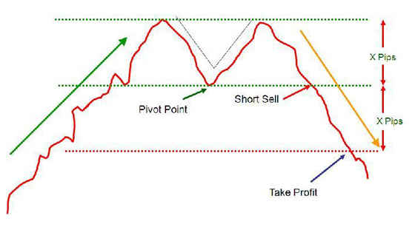

A double top formation is a distinct chart pattern characterized by a rally to a new high (peak1 or resistance1) followed by a moderate pull back to the pivot point or neckline support level and then again a second rally to another peak (peak 2 or resistance 2). The second peak is almost equal to the first peak.

Now if the market pulls back from the second peak and breaks below the neckline level then it makes our double top pattern.

## How to Trade Double Top?

Double top pattern comes into picture only if the price action falls below the neckline level from the second peak. Considering this we can enter a limit order for short-selling just below the neckline.

We can place a stop-loss order slightly above the second peak. Stop-loss order level would also depend on the height of the peaks and the momentum of the drop. If the downward momentum is strong then the stop-loss can be narrower.

Please note that many times there will be some pull-back after the price breaks below the neckline and hence it may be a good idea to wait for some time to short-sell at slightly higher price.

The first profit target would be at least equal to the distance from the neck line to the level of the two peaks or the double tops, as indicated in the above diagram.

## Double Top Chart Examples

Let's have a look on the following 3 charts to see how a double top chart formation looks like and how to trade it.

#### Example 1

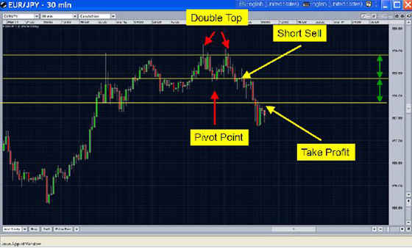

The chart above shows Double Top pattern on EUR/JPY 30 Min chart.

#### Example 2

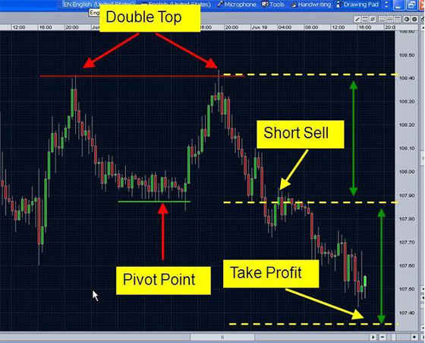

The chart above shows Double Top pattern on USD/JPY hourly chart.

#### Example 3

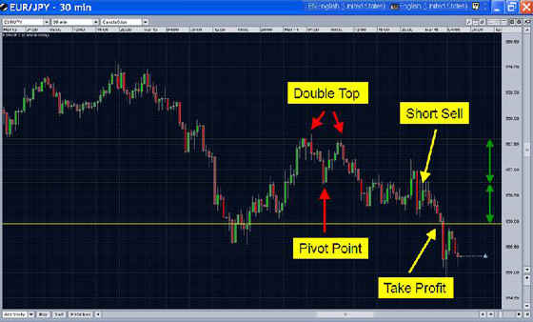

The chart above shows Double Top pattern on EUR/JPY 30 Min chart.

# Double Bottom Chart Pattern

Double bottom pattern is one of the most common chart formation. It signifies the fear of further downward moves and hence indicates further gains or even the possibilities of a reversal.

Double Bottom formations, like double top, are reversal patterns which take place during a downtrend. Double Bottom formations are two consecutive lows of same or almost same height with a pullback upwards in between which can be called a pivot point or neckline.

Double bottom patterns works on charts of any time-frame but can prove to be a major reversal pattern on longer time-frame charts like daily charts, especially after an extended downtrend. This pattern is confirmed when the price moves up from the second peak and breaks above the neckline. The break of the neck line resistance indicates further upward gains.

## Example

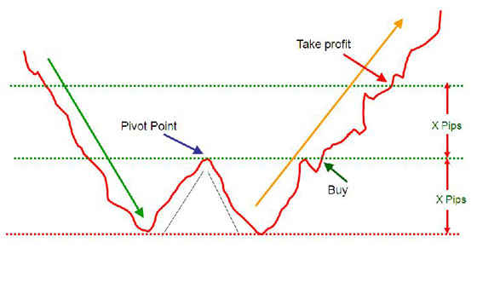

A double bottom formation is a distinct chart pattern characterized by a fall to a new low (Bottom 1) followed by a moderate pull back to the pivot point or neckline resistance level and then again a second fall to a low (Bottom 2). The second bottom is almost equal to the first bottom.

Now if the market pulls back above the pivot point or neck line, it makes our double bottom formation.

### How to trade Double Bottom formation?

Double bottom pattern comes into picture only if the price action breaks above the neckline level from the second bottom. Considering this we can enter a limit order for a long position just above the neckline.

We can place a stop-loss order slightly below the second bottom. Stop-loss order level would also depend on the depth of the bottoms and the momentum of the upward jump. If the upward momentum is strong then the stop-loss can be narrower.

Please note that many times there will be some pull-back after the price breaks above the neckline and hence it may be a good idea to wait for some time to enter a long position at slightly lower price.

The first profit target would be at least equal to the distance from the neck line to the level of the double bottoms or the lows, as indicated in the above diagram.

#### Double Bottom example

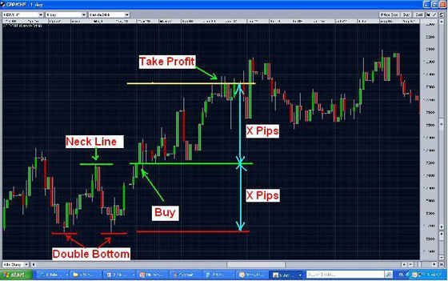

The chart above shows double bottom formation on daily chart of GBP/CHF.

# Triple Top Chart Pattern

Triple Top chart pattern is not as common as double top but works in exactly the same way. Triple Top formations are reversal patterns with bearish sentiments. A triple top pattern is identified by three consecutive highs almost at the same level and with two moderate pull backs to a neckline in between. The neckline represents the support level. Such patterns indicate a strong resistance at the same level, time and again, and that in turn indicates the possibilities of a reversal.

Triple top patterns works on charts of any time frame (short time frame or longer time frames like daily charts) but can be a major reversal pattern on longer time frame charts like daily charts, especially after an extended uptrend. This pattern is confirmed when the price goes down from the third peak and goes below the support of the neckline. Most of the time this break of the support brings deeper declines.

## What does a Triple Top formation look like?

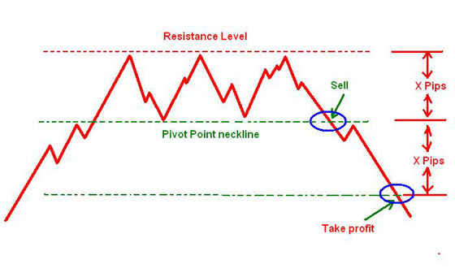

A triple top pattern is a distinct chart pattern characterized by a rally to a new high (peak 1 or resistance 1) followed by a moderate pull back to the pivot point or neckline support level and then again a second rally to the peak 2, followed by again a moderate pull back to the neckline. And finally a third rally to peak 3. All these three peaks are approximately at the same level and represent a strong resistance at that level.

Now if the price pulls back below the neck line, it makes the triple top formation and signals a short-selling opportunity.

### How to trade Triple Top?

When the price breaks below the neck line, we can enter a short-selling position. Many times even after the break of this support there are some upward pullbacks. If we can enter a trade when this pullback takes place, it may increase our gains. The caution is required to check if the pullback is not very strong and does not represent a failure of the pattern.

The profit targets would be equal to the distance from the neck line to the three peaks. The above diagram explains it clearly.

#### Example of Triple Top Pattern

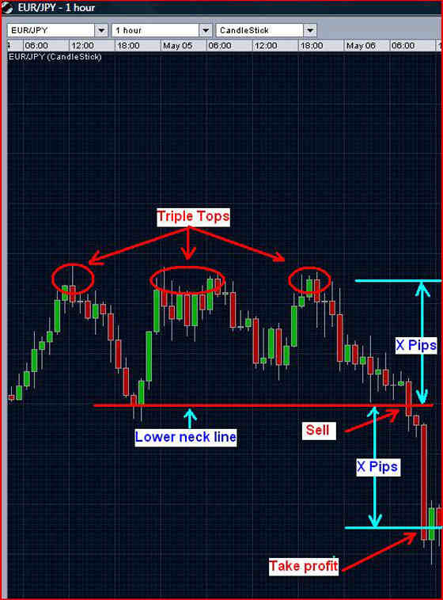

The above chart shows Triple Top formation on EUR/JPY 1 Hour.

# Triple Bottom Chart Pattern

Triple Bottom chart pattern is not as common as double bottom but works in exactly the same way. Triple Bottom formations are reversal patterns with bullish sentiments. A triple bottom pattern is identified by three consecutive lows almost at the same level with two moderate pull backs to a neckline in between. The neckline represents the resistance level. Such patterns indicate a strong support at the same level, time and again, and that in turn indicates the possibilities of a reversal to upside.

Triple bottom patterns works on charts of any time frame (short time frame or longer time frames like daily charts) but can be a major reversal pattern on longer time frame charts like daily charts, especially after an extended downtrend. This pattern is confirmed when the price goes up from the third peak and breaks the resistance of the neckline. Most of the time this break of the support brings further upward moves.

## What does a Triple Bottom formation look like?

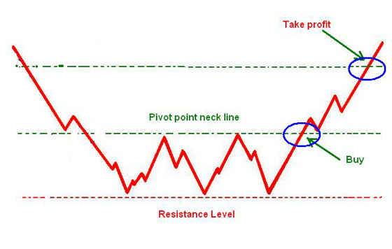

A triple bottom pattern is a distinct chart pattern characterized by a drop to a new low (bottom 1) followed by a moderate pull back to the neckline (resistance level) and then again a second drop to the second bottom, followed by a moderate pull back to the neckline or support level. And finally a third drop to the third bottom. These three bottoms are at approximately the same level and represent a strong support.

Now if the price pulls back above the neck line then it makes the triple bottom formation and signals an opportunity for a long position.

### How to trade Triple Bottom?

When the price breaks above the neck line, we can enter a long  position. Many times even after the break of this resistance there are some downward pullbacks. If we can enter a trade when this pullback takes place, it may increase our gains. The caution is required to check if the pullback is not very strong and does not represent a failure of the pattern.

The profit targets would be equal to the distance from the neck line to the three bottoms. The above diagram explains it clearly.

#### Example

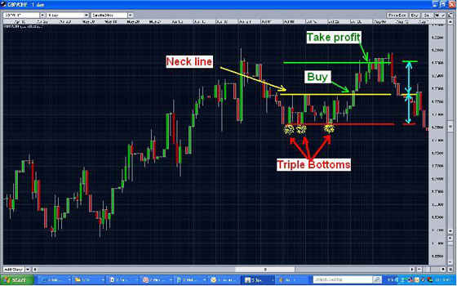

The above chart shows Triple Bottom formation on GBP/CHF Daily Chart

# Head and Shoulders Chart Pattern

Another of our favorite and also the most occurring patterns in trading.  
  
The Head and Shoulders formation indicates a reversal in an uptrend market and is extremely popular in trading. Head and Shoulder formation consists of the following:

1. A peak (left shoulder) and then a pull back to lower level (neck line or pivot point)
2. Second peak higher than the first peak. This is called as Head and then a pullback. This pull back may not be equal to the previous pullback.
3. A third peak (right shoulder) which is less than the head and then again a pullback to the neckline/pivot point level and then below the neck line.

The neckline can be horizontal, slope up or slope down and is formed by drawing a line connecting two low points of the formation.

## What does a Head & Shoulders Top reversal chart pattern look like?

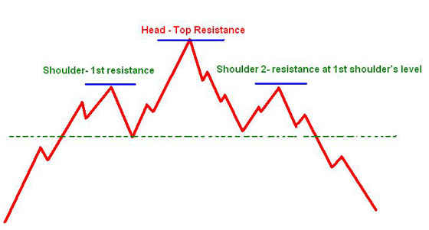

The pattern is complete when the support shown by the neckline is “broken." This happens when the price, falling from the high point of the right shoulder, moves below the neckline.

Unlike the Double Top, we should wait a little more downward movement before going short (a bit of more confirmation).  
  
The reverse of Head & Shoulders (Head & Shoulders Bottom) also happen during a downtrend and we can trade in opposite way.

### How to trade Head & Shoulder Top Reversal Chart pattern?

Go short (sell) when the price goes below (closes for that period below) the neckline. Put a stop-loss a few pips above the previous peak i.e. the right shoulder.

We may target the take-profit target of 1.5 times the height of the right shoulder from the neck line i.e. if the peak of right shoulder is 100 pips above the neck line, we may target to take profit at 150 pips below the neckline.

#### Head & Shoulder Pattern - Example 1

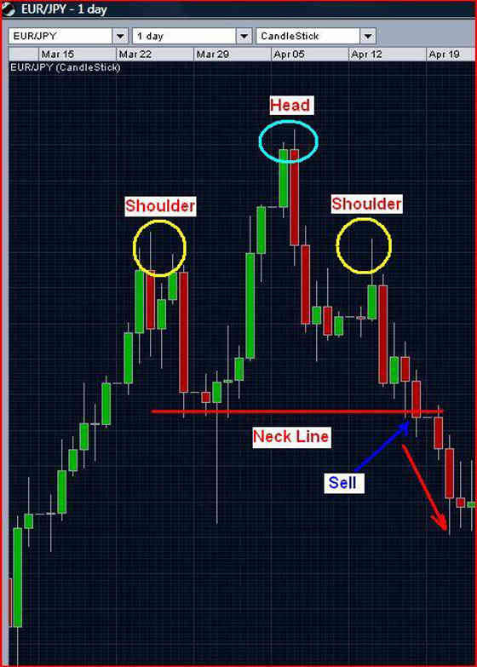

EUR/USD 1 Hour Head & Shoulders Top reversal pattern

#### Head & Shoulder Pattern - Example 2

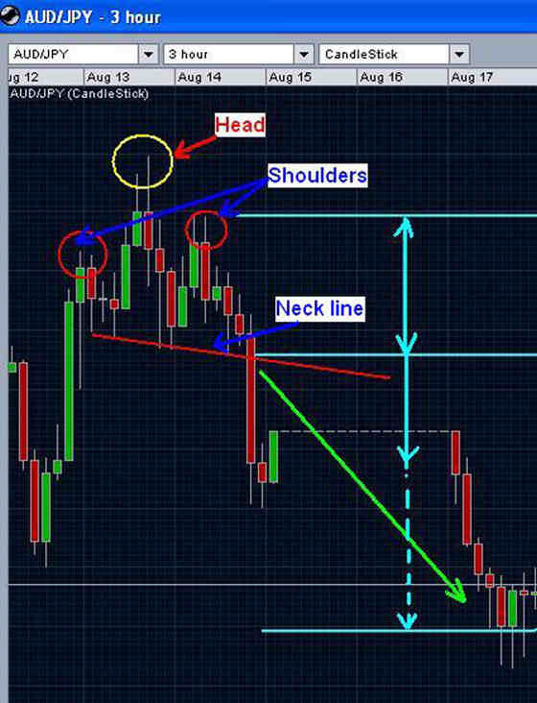

The above chart shows Head & Shoulders formation on a 3-hourly chart of AUD/JPY.

Please note that the Head and Shoulders Top formation does not need to be perfectly symmetrical i.e. the left and right shoulders may not be of the same heights and the neck line may not be perfectly horizontal. It is clear in the above chart of AUD/JPY, where the right shoulder is higher than the left and the neckline is slopping downwards.

The reverse of Head & Shoulder pattern (bottom reversal) also works in the similar way but in opposite direction i.e. the market can be expected to move up.

# Ascending Triangle Chart Pattern

As the name suggests, the ascending triangle chart pattern has two converging trend lines (trend lines for support levels &resistance levels) and the support level trend line slops upwards (the green line in the following diagram). This is a bullish formation that usually takes place during the uptrend.

Ascending Triangle pattern is confirmed when there is a break above the ascending triangle formation and goes above the trend line of resistance (the red dotted line in the following diagram). Please note that if there is a breakout downwards (below the red dotted line in the following diagram), it may indicate the reversal in the trend.

## What does an Ascending Triangle Formation look like?

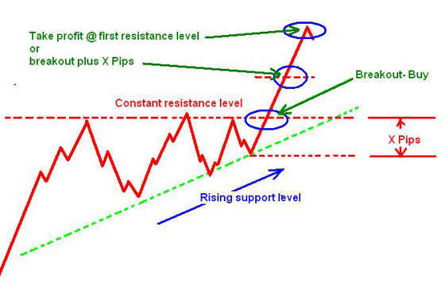

The ascending triangle has two trend lines. At the top, there is resistance trend line (the red dotted line in the diagram above), where traders are either selling or taking profit on the bought positions. And at the bottom we have a rising support trend line where traders are buying.

The support trend line is rising in slope and shows that support level is increasing. The resistance trend line is almost horizontal. When this resistance level is broken, we can look forward to an upward movement.

### How to trade with Ascending Triangle pattern?

Buy when there is a breakout (upwards) of the upper resistance trend line of the ascending triangle formation. Take profit at the first resistance level. In two lot-strategy, take profit on one lot at first resistance level and wait for the second lot by increasing your stop-loss for that order higher.

### Ascending Triangle Pattern - Example 1

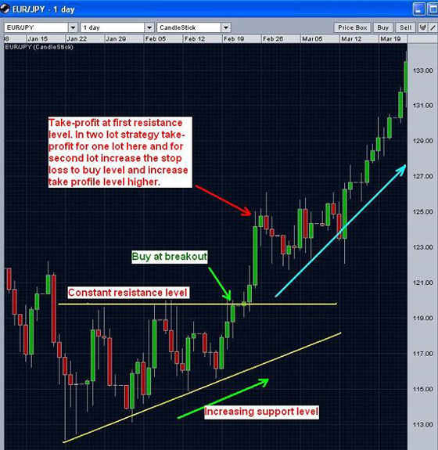

The above chart shows ascending triangle formation on EUR/JPY daily chart.

# Descending Triangle Chart Pattern

This pattern is just reverse of the ascending triangle chart pattern. it has two converging trend-lines. The upper resistance trend line (red dotted line in the diagram below) slops downwards and the support trend line (green dotted line in the following diagram) is almost horizontal. Descending triangle is a bearish formation that usually forms when there is a downtrend and indicates possibilities of further downward move.

This pattern is confirmed when there is a breakout of the descending triangle formation below the support trend line (the green dotted line in the diagram below). Please note that if there is breakout to the upside (upwards and above the red dotted line in the following diagram), it may indicate the reversal in the trend.

## What does a Descending Triangle Formation look like?

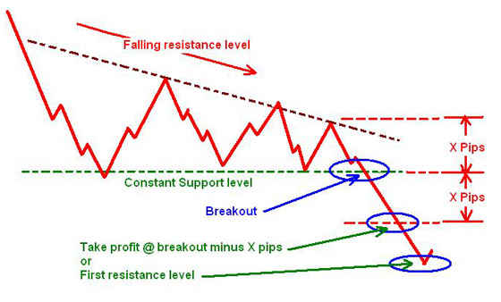

The descending triangle is marked by two important trend lines. At the top, there is a line of resistance for the upward movement (the red dotted line). The resistance trend line is slopping down i.e. the resistance is increasing. The support line (green dotted) is almost horizontal. Now with increasing resistance for upward movement when the support line is broken, the price tends to go further down.

### How to trade Descending Triangle Pattern?

Sell when there is a breakout of the descending triangle formation downwards. Take profit at the first resistance level. In two lot strategy, take profit on one lot at first resistance level and wait for the second lot by lowering down your stop-loss for that order higher.

#### Descending Triangle Chart Pattern - Example 1

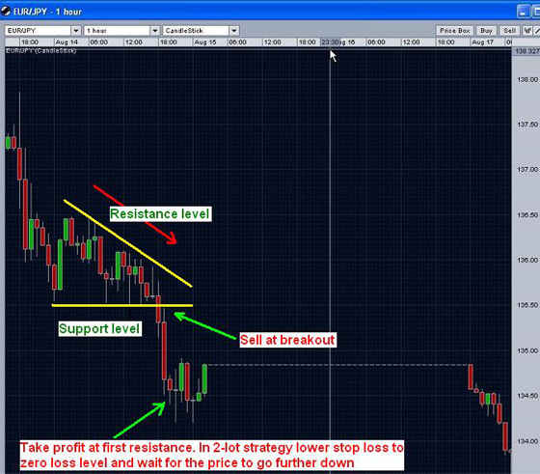

The above chart shows Descending Triangle formation on EUR/JPY 1 Hour Chart.

## Trend Lines

Look out for the breakouts. Using trend lines can do wonders. Using these simple and chart patterns which occur frequently along with the [technical analysis](http://www.forexabode.com/technical-analysis), while keeping an eye on the fundamentals always helps in improving the success ratio in trading.

# Common Mistakes in Trading

Every trader has different psychology and personal traits but still there are some trading mistakes which traders make quite commonly. On one side we need to check on personal characteristics to have a better discipline in our trading but on the other hand we also need to focus on avoiding these common mistakes. Avoiding these mistakes is the first step for building a successful trading career.

## Top Trading Mistakes

### My trading mistake or someone else's fault?1. Always entering the market against Trend

It may happen that the market go into a trend in the opposite direction than what we might have thinking. We might have been thinking that the price would fall but the price starts going up. In such situations we tend to hope that sooner or later the price would fall and with every big move we try to short-sell. What actually happens that the trend continues and out trades end up in loss by hitting the stop-loss orders. What we are doing is ignoring the facts that the trend is strong and becoming a slave to our emotions and hope against all the analysis and the facts.

Such actions are possible from time to time and at times our judgment may prove to be correct. However, if this loss-making continues as a pattern then it needs a deeper analysis and better control over our trading decisions.

We can't rebel against the market rather we need to understand it and be with the flow of it. Also markets movements cannot be predicted every time because it is not run and controlled by definite factors and a small group of entities.

Every trend reverses and its always a cycle but what is important is to try to figure out the levels where it may reverse and not just to keep going with our emotions and egos.

### 2. Taking a position too late

Some of us take risks easily while some of us are risk averse. The extreme to any side goes against good trading decisions. If we are a completely risk averse person then speculative trading is not meant for us. Forex trading is not our game then because we would tend to see 100% confirmation of the market trends. The fact is that in dynamic markets like Forex market there is nothing for which you can be 100% sure. When we enter the market (buy or sell), there is always a risk. We need to take optimum risks than to keep on waiting for confirmation and reconfirmation about the trend because by the time we decide to take a position the prices may be on the verge of reversal.

The opposite of the above is also true and that is to take a position too soon.

### 3. Adding trade positions against the trend

This pattern takes place with those of us who are weak in facing any kinds of losses or are gamblers in nature and also have high egos.

Let's assume that we take a long position. Instead of going up as we had expected, the prices start going down. We are so bound by our emotions, hopes and egos that we are sure that the prices are going to move up. We are so sure that we take it as an opportunity to buy more so that our profits would be more. We immediately buy more. It goes further down and we still buy more. Now either we get thrown out of the market because of a margin call or by the time we decide to come out the losses are already too big.

This mainly happens because we become too egotistical to accept that we were wrong. As soon as the market starts telling us that the decision could have been wrong, the combination of the fear to lose, the ego that how could we be wrong and the fear to lose come into the play. This results in either buying more as an effort to maximize the profits or thinking that a slight reversal would at least balance the loss we might make on our first position.

In certain situations adding to your losing positions may get you nice profits. It generally can happen when market has gone too far in one direction and a reversal may be around the corner. But if such actions take place as pattern in different kinds of market situations, it would just wipe out the accounts, certainly, on one fine day. As they say that the trend is a friend and being cautious is better than being caught in complete uncertainty.

No one can be emotionless but emotionless but a trader needs to be in control of the emotions. Egos will be there, greed will be there and fears will be there but how to balance those out by controlling those so those emotions work in our favor and not against us is the key for the success.

### 4. Trading addiction and trading with emotions

****By nature some people are prone to addictions while some have better abilities to avoid addictions in life. If we are prone to addictions then there is a good possibility that trading may become an addition. It should be avoided at all cost. We need to take trading positions when we are pretty sure about a directional move and should strictly avoid to trade just for the sake of trading. We do not have to be in the market all the time. The trading platform is not a video game. Working on our platform is serious business. It’s our hard earned money which we are putting in the trade and that needs to be put to earn more and not to keep us engaged.

There are times when we are not at all sure about the market behavior. The price action may either be just running in a very narrow range or it may just be having a very volatile moves lacking in a clear direction. Because we are addicted to our trading and can't keep ourselves away, we take positions just because of hope without the backing of a real analysis or logical reasoning. This may prove to be very costly if this happens in a pattern, time and again,

There are times when it is better to be away. Always ask the following questions before taking a position:

* Am I reasonably sure that the market would move in the direction I am expecting?
* If I am reasonably sure then what are the reasons/logics backing my decision?

### 5. Stop-loss orders too close or too far

* Stop-loss orders too close: We may be subconsciously or consciously worried that market may move against the direction of our position and we want to cut our losses to the minimum. This may make us having a very narrow stop-loss order.
* Stop-loss orders too far: We may be subconsciously or consciously worried that market may move against the direction of our position. And We don’t want to have our stop-loss order closing the position before the market reverses and moves back in the expected direction.

Well, in both the cases there is a feeling in the sub-conscious mind that market would go against our expected direction. The first thing is that in such cases we should avoid taking any position or should use limit orders rather than market orders. In case we are reasonably sure that price action may have some consolidation before going in the expected direction than the stop-loss levels should be optimum otherwise either we certainly make a loss or make a big loss.

### 6. Take-profit orders too close or too far

#### Take-profit orders too close:

When we are worried that the market may have some consolidation in the opposite direction very soon than what we are thinking and but still we wish to trade and make some profits.

#### Take-profit orders too far:

Trying to kill all the birds with one shot? Make all the money with one trade?

Same as what we talked above about stop-loss levels, either we should avoid taking a position or put a limit order rather than a market order. Take-profits should be optimum . Very narrow take-profit targets would be like cutting down the opportunities and make a loss in the possible profits and very high profit targets may cause the market reversal before the target hits and may cause a loss ultimately.

Nobody becomes rich in one day. The markets move in a cycle. Even during a strong trend the prices will have corrections before the move continues. And we cannot be absolutely sure whether it would prove to be just a correction or a reversal.

Keeping the take-profit orders too far with too much optimism is dangerous. And keeping those too low for quick profits is also equally dangerous. There is nothing like a quick profit or too much profit. Being reasonable only brings us reasonable profits.

### 7. Learning from the past mistakes and making a bigger mistake

Learning from past mistake is always required but not in the absolute terms. In a dynamic market like Forex, what was true last time may not hold good in the current, and possibly changed, situation.

One example of this was mentioned earlier in this write-up that we put stop-loss order very close in one trade, the market goes against us and our stop-loss order closes our position with a loss. After hitting the stop-loss level, the market reverses and goes in the previously expected direction. We learn from this mistake and next time we put the stop-loss very far. The market goes against us and keeps on going against. We end up having a much bigger loss..

There could be various ways that we can make such mistakes. Suppose we have been expecting the market to go up. We buy but it goes down and we make a loss. We buy again and make further loss. After some time we get frustrated and we short-sell. The market moves up and well, another loss. Every new trade is a fresh start. Learning from the past failures and successes is important but those failures and successes should not influence the current trade. Every trade is different and every situation is different and we need to apply our past learning and experiences according to the situations and not in a literally and absolute way

In a dynamic market the strategies also need to be dynamic. Checking and rechecking the decisions about the entry points, exit points, where to put stop-loss and what should be the position size are very important and should change with the changing market conditions. We need to see if any of these decisions is getting influenced by past losses or past profits.

### 8. Loving our trades and bias for the market direction or numbers

As far as loving our trades and bias for market direction is concerned, it is similar to point number 3 above. Many of our trading decisions would go wrong and that’s the reason that a good risk-reward ratio has to be maintained so that the profit margin of each trade is more than the possible losses. This was even if 50% of our decisions go wrong, we end up with a net profit. If we are biased about the market direction and love each position we take trades, we would fail to hear what the market is telling us. It’s important to hear what the market is indicating than to go ahead with only what we think.

Apart from the direction we need to avoid any bias about the numbers. We may be biased about the numbers in two ways. Bias for the price of any currency pair or about the profits we want to make out of a trade or during a period of time.

* Bias for the price level: Sometimes we may get stuck with the idea that certain price level is the normal price level for a currency pair and the pair would come back to that level regardless of the current movement. For example if we have seen USD/JPY to move a lot in the range of 115 to 125, we may start thinking that 115 should be the normal level for this currency pair to reach even if has gone down suddenly to 110. Well, that may happen but what may also happen that the downtrend continues and the price goes to a new low. There is nothing which can be considered as the "average" in the market. Prices can go to all time high and crash to unexpected bottom. Market always has surprises for us and we need to be ready to take the surprises.
* Bias about the profit levels: Well it may happen either when we have made some good profits in the recent past or have made big losses. We may end up setting some impractical or unrealistic profit targets for each day or week or month. Doing such a thing only creates unnecessary pressures and the resulting stress may result in wrong decisions and hence loss making trades. Out of the panic that we are not meeting our targets, we could make some more wrong decisions and that would further add to our losses. A goal for desired profits is required but not for very short periods like every day or every week. Do it for little longer time frames. And even if you wish to do it for shorter time frames, don’t panic. It’s the average profitability which counts. Fix up the goals but don’t panic.

### 9. Trading too big for the account size

It’s practically impossible to buy when the prices are at the rock bottom and take profit when they are at the peak. Similarly it's not possible to get the peaks for a short-selling trade. In other words it’s simply not possible to pick the peaks and bottoms most of the time. It is always possible that even though our analysis was good but after entering a trade price may move in the opposite direction for some time. If the position size is too big then those few pips in the opposite direction may wipe out the account. Always keep an eye on your trading account size and keep an eye on the [margin requirement](http://www.forexabode.com/forex-broker/margin-calculation/).

We should not just think as to how much we can make but also keep in the mind as to what could be the possible losses.

### 10. Varying the trading position size

Let's assume that we are continuously in profit and we multiply our position size in the next trade and it goes in opposite direction. Or we are losing continuously and we decide to multiply our position size expecting a gain which would balance our previous losses. The third example could be that we are continuously gaining and we make our position size very small for the fear of losing in the next trades and end up smaller profit than what otherwise we could have in this winning trade. Once we realize that we could have made more and lost the opportunity, we enter into a very large position and end up making a big loss in that trade.

It never pays in varying the position size because of panic, greed, optimism or pessimism. Keeping the [position size](http://www.forexabode.com/trading-tools/position-size-calculator/) balanced, not only thinking of what we can lose or gain but what profit size is reasonable and how much loss we can afford reasonably is another key for long-term success.

### 11. Not looking at the long-term and short-term pictures of the market

Let's say that we are following only the daily chart, and our analysis on that gives us a clear indication that the price is having a strong uptrend and there is an opportunity to take a long position right now. Now at the same time a shorter-term chart, say 4-hourly or hourly, may be giving a signal that there is a possibility for some downward consolidation. In case we put a trade just on the basis of the readings of the daily chart then we may either miss the opportunity to make some larger profits or put a wrong stop-loss order which may close the position before the prices move up again.

The opposite of the above is true that a decision based solely on a short-term chart may prove to be wrong. Keeping an eye on both, the shorter-term situation and longer -term situation make the decisions better.

### 12. Trading without stop-loss order- THE ULTIMATE KILLER

The only thing we would like to say about this point is that “SIMPLY DON’T DO IT”.

You may be afraid that the market going may go to the opposite direction before it goes back in your expected direction or you may be too confident that even if it goes in opposite direction, it would go back in your expected direction. Well, both fear and confidence here are pointing towards the same thing that you are not confident about your decision. But even if you are confident, PLEASE PUT A STOP LOSS ORDER AT REASONABLE OR EVEN UNREASONABLE LEVEL. If you don’t like it, it's better to stop yourself from trading otherwise one day the market will stop you forever.

Understanding ourselves is the first step before we try to understand the market. If we can overcome these common mistakes in our day-today trading then half of our job is done.